**RETAIL STORE STOCK INVENTORY ANALYTICS**

**NALAIYA THIRAN PROJECT BASED LEARNING**

**on**

**PROFESSIONAL READINESS FOR INNOVATION, EMPLOYABILITY AND ENTREPRENEURSHIP**

**A PROJECT REPORT**

|  |  |
| --- | --- |
| SUBASH V | 111919205039 |
| KARTHICK B | 111919205018 |
| RANJITH KUMAR S | 111919205034 |
| VIGNESH V | 111919205050 |

**BACHELOR OF ENGINEERING**

**IN**

**COMPUTER SCIENCE AND ENGINEERING**

**HINDUSTHAN COLLEGE OF ENGINEERING AND TECHOLOGY**

Approved by AICTE, New Delhi, Accredited with ‘A’ Grade by NAAC

**(An Autonomous Institution, Affiliated to Anna University, Chennai)**

**COIMBATORE – 641 032**

## November 2022

**S.A ENGINEERING COLLEGE**

**Approved by AICTE, New Delhi, Accredited with ‘A’ Grade by NAAC (An Autonomous Institution, Affiliated to Anna University) Thiruverkadu,Avad,iPoonamalle Road,**

**Chennai – 600 077**

**INTERNAL MENTOR**

SENTHIL.P, M.E., Assistant Professor,

Department of Information Technology,

S.A Engineering College, Chennai-600077

**INDUSTRY MENTOR**

## Shivani Kapoor,Rakesh Miskin

**TABLE OF CONTENTS**

|  |  |  |
| --- | --- | --- |
| **CHAPTER NO** | **TITLE** | **PAGE NO** |
|  | **ABSTRACT** |  |
| **1** | **INTRODUCTION** | **1** |
| **2** | **OBJECTIVE** | **3** |
| **3** | **IDEATION PHASE** | **5** |
|  | **3.1 Literature Survey** | **6** |
|  | **3.2 Empathy Map** | **7** |
|  | **3.3 Ideation** | **8** |
|  | **3.4 Problem Statement** | **12** |
| **4** | **PROJECT DESIGN PHASE 1** | **13** |
|  | **4.1 Proposed Solution** | **14** |
|  | **4.2 Problem Solution Fit** | **15** |
|  | **4.3 Solution Architecture** | **16** |
| **5** | **PROJECT DESIGN PHASE 2** | **17** |
|  | **5.1 Customer Journey Map** | **18** |
|  | **5.2 Solution Requirements** | **19** |
|  | **5.3 Data Flow Diagrams** | **21** |
|  | **5.4 Technology Stack** | **24** |
| **6** | **PROJECT PLANNING PHASE** | **26** |
| **6.1 Prepare Milestone and Activity List 27** | |
|  | **6.2 Sprint Delivery Plan** | **29** |
| **7** | **PROJECT DEVELOPMENT PHASE** | **35** |
| **7.1 Project Development - Delivery of Sprint – 1 36** | | |
| **7.2 Project Development - Delivery of Sprint – 2 45** | | |
| **7.3 Project Development - Delivery of Sprint – 3 52** | | |
| **7.4 Project Development - Delivery of Sprint – 4 57** | | |
| **8** | **CONCLUSION** | **61** |
| **9** | **REFERENCES** | **62** |

**ABSTRACT**

Inventory Management System is important to ensure quality control in businesses that handle transactions revolving around consumer goods. Without proper inventory control, a large retail store may run out of stock on an important item and it's also easy to lose its possible customer if they do not have sufficient stocks in the store.

A good Inventory Management System will alert the retailer when it is time to reorder. Inventory Management System is also an important means of automatically tracking the stocks of their product. For example, if a business orders ten pairs of socks for retail resale, but only receives nine pairs, this will be obvious upon inspecting the contents of the package, and error is not likely. On the other hand, say a wholesaler orders 100,000 pairs of socks and 10,000 are missing. Manually counting each pair of socks is likely to result in error. An automated Inventory Management System helps to minimize the risk of error. In retail stores, an Inventory Management System also helps track theft of retail merchandise, providing valuable information about store profits and the need for theft-prevention systems.

The product quantity is updated by the store operator every time a product is bought/received. This information is then tracked by a central computer system. The Inventory Management System can serve a variety of functions in this case. It can help in identifying the overstock and under stock products prior. It also provides sales insights and stock reports in the form of graphs/ charts which will be useful for easier visualization. All of this data works in tandem to provide businesses with real-time inventory tracking information. Inventory Management Systems make it simple to locate and analyze inventory information in real-time with a simple database search.

### INTRODUCTION

Analytics is the discovery and communication of meaningful patterns in data. As a topic, analytics has found its way from being discussed at the sidelines of industry and technology conferences, to the top of the corporate agenda. With the existing promise of delivering performance improvements not seen since the redesign of core processes in the 1990s, these tools are likely to change the competitive landscape in many industries in the years to come.

Big Data is all about the non-traditional ways of dealing with the modern digital data. We exist in an ocean of digital data. It includes data stored in piles of well-structured databases residing with organisations, streams of data generated from the dynamic social networks, various understandable and intangible signals generated by all kinds of digital equipment all over the place. For an organisational, Big Data can be about identifying the right datasets from large amount of data commonly defined by the three Vs - Volume, Velocity and Variety; transforming them into readily consumable models; and then extracting meaningful insights for devising business strategies. These insights can be used to improve different aspects of the business - from marketing and sales, to research and operations, and customer services.

Big Data enables clients in the retail Industry to track and better understand a variety of information from many different sources like CRM, AdWord/AdSense analytics, inventory management system, emails, transactional data, sensors data etc. Industry can identify the current trends, re-order supplies for hot-selling items, adjust the prices in real time and also manage and control product distribution across different stores to channelize their sales in more effective manner. This provides retail industry with entirely different perspectives of looking towards the datasets available at their disposal. By collating these organisational datasets with social media data streams, they can also use it for better sales predictions, designing relevant campaigns to suit their profitable customers and thereby ensuring customer satisfaction.

Retail inventory management is the process of ensuring you carry products that shoppers want, with neither too little nor too much on hand. By managing inventory, retailers meet customer demand without running out of stock or carrying excess supply. Inventory management is vital for retailers because the practice helps them increase profits.



They are more likely to have enough inventory to capture every possible sale while avoiding overstock because too much inventory means working capital costs, operational costs, and a complex operation.

Based on the inventory management analysis we can manage how much inventory is required for selling the product based on which they can calculate the profit and losses.

Our dataset contains a lot of historical sales data of a Brazilian top retailer

Basic Questions of every retailer: How much inventory should I carry? Too much inventory means working capital costs, operational costs and a complex operation, lack of inventory leads to lost sales, unhappy customers and a damaged brand.

This is why short-term forecasting is so important in the retail and consumer goods industry.

### OBJECTIVE

By the end of this Project, you will:

Know fundamental concepts and can work on IBM Cognos Analytics. Gain a broad understanding of plotting different visualization to provide suitable solution,Able to create meaningful Visualization and Dashboard(s).

**Primary objective:**

### Identifying Consumer Demands:

The first task that a retailer has to perform is to identify the consumer needs and wants. The retailer does not provide raw materials, but offers finished goods and services in a ready-to-use form that the consumers want. For this, from time-to-time, retailer gathers information about consumers’ liking, disliking, tastes and preferences.

### Management of Merchandise:

The second task that a retailer performs is the management of merchandise. The retailer performs the function of storing the merchandise and provides as and when required by the customer.

### Convenience of timing:

The retailer creates time utility by keeping the store open and ready for sale according to consumers’ convenience. The new trend in retailing to longer trade hours reflects the socio-cultural changes where over one in ten people work outside normal hours resulting in changing trading hours and panacea for small retailers against the cheaper prices of the super stores and other retail chains. By being available at a location that has easy access and convenient to shop, retailer creates place utility. Finally, when selected and bought by customers, retailers create ownership utility.

In short, retailers are not only the final link between the consumers and the manufacturers but a vital part of modern business world. In the absence of retailing, one can easily imaging how difficult and costly for a consumer to approach a manufacturer for various things every time he wants. Retailers do not sell things in small quantities but make their shopping convenient and less risky.

Retailers have floor staff to answer their queries regarding how to use effectively and safely, guide them what to buy according to individual preferences and budget and give demonstration or display products so that the consumers should have a feel of the merchandise before buying. The successful retailer focuses its activities on meeting these objectives through effective marketing.

### Retail Sales Goals:

Retail Sales measures the gross receipts of a retail store by selling durable and nondurable goods. The main components of retail sales are grocery, food & clothing and shoe retailing. In India, consumer spending roughly accounts for over 60% of GDP and is therefore, a vital element in the country’s economic growth. Any change in retail sales pattern is important and is seen as the timeliest indicator of wide consumption patterns. Retail sales may have short term and long term goals in nature. Short term retail sales goals are supposed to support and merge into long term goal.

**3.IDEATION PHASE**

* + 1. **LITERATURE SURVEY**

1. Inventory management in retail industry - Application of big data analytics

Author : Hien Vu

https:/[/www.rese](http://www.researchgate.net/publication/329526158_Inventory_man)a[rchgate.net/publication/329526158_Inventory_man](http://www.researchgate.net/publication/329526158_Inventory_man) agement_in_retail_indu stry_-_Application_of_big_data_analytics

Retailers are faced with a dilemma where neither an excess of inventory on hand nor a running out of stock is negotiable as the retail sector becomes increasingly highly competitive and narrowly profitable. A thorough analysis of important inventory management strategies that have historically been employed by retailers on a large scale. The trade-off between shortage cost and overage cost is identified in the paper as the fundamental issue with inventory management. Once more, the "performance frontier" graph shows that introducing innovative is a practical way to change the efficiency curve. BDA is that innovative in this scenario. The research identifies opportunities for incorporating BDA into traditional inventory management methods and boosting the applicability and feasibility of these models in the big-data environment.

1. Inventory management for retail companies: A literature review and current trends Author : 1.Cinthya VanessaMunoz, Jorge Andres Espinoza Aguirre, RodrigoArcentales-Carrion & Mario Pena

https:/[/www.rese](http://www.researchgate.net/publication/352235223_Inventory_man)a[rchgate.net/publication/352235223_Inventory_man](http://www.researchgate.net/publication/352235223_Inventory_man) agement_for_retail_co mpanies_A_literature_review_and_current_trends To identify the primary trends and indicators of inventory management in Small and Mediumsized Enterprises, a systematic literature study was conducted (SMEs). The five-year study period between 2015 and 2019 mainly focuses on the retail industry. The main findings of this study include the top inventory control and management models, the Key Performance Indicators (KPIs) for managing them correctly, and the advantages and difficulties of selecting or implementing an effective system

* + 1. **EMPATHY MAP**

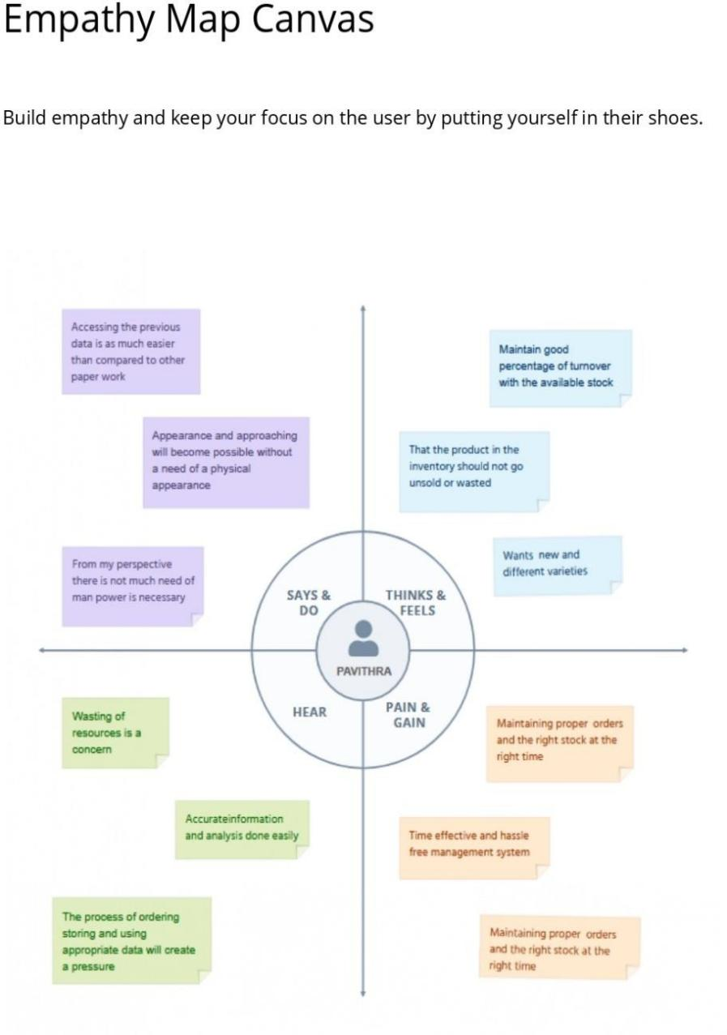

* + 1. **IDEATION PHASE**

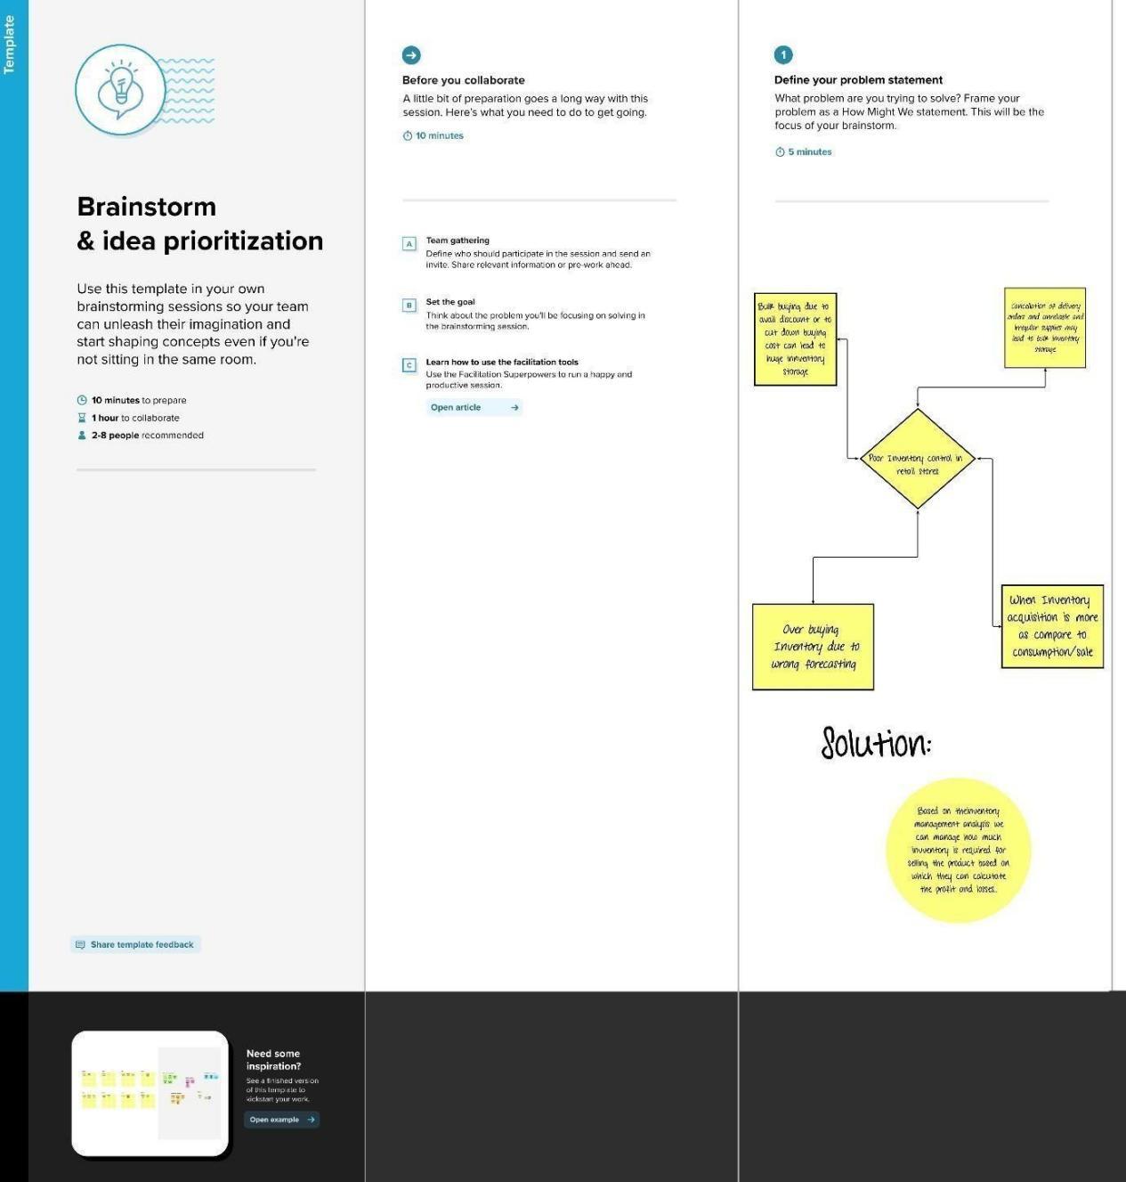Step 1:

Step 2:

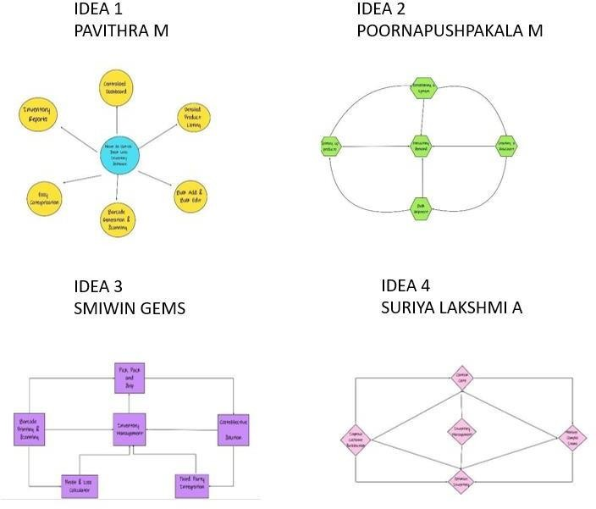

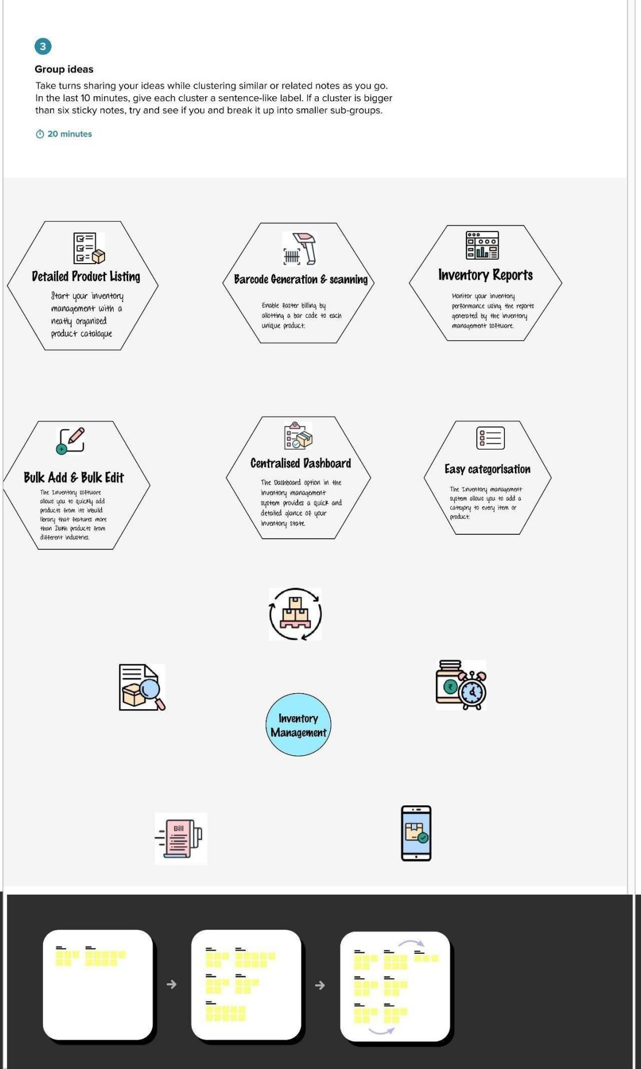

Step 3:

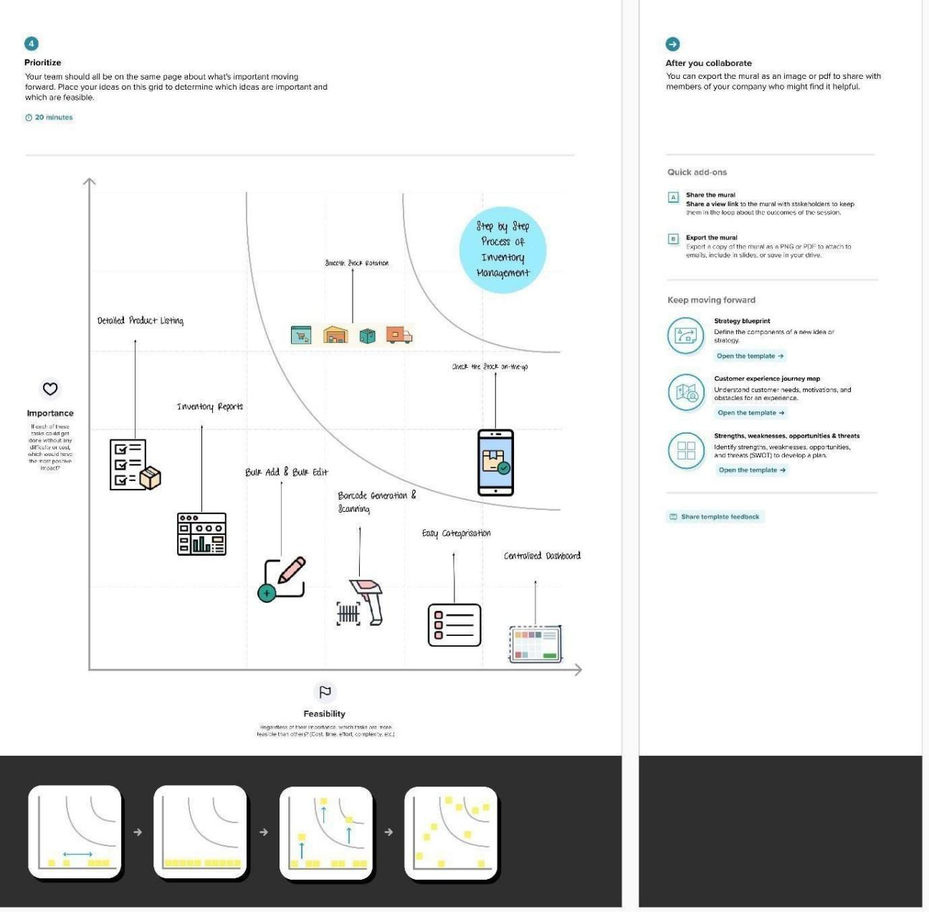

* + 1. **PROBLEM STATEMENT**

**Problem Statement 1:**

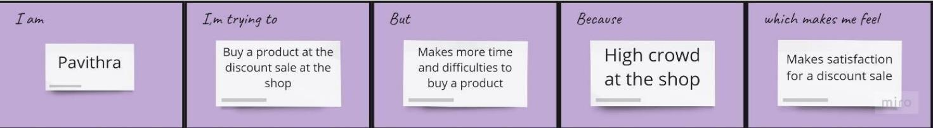

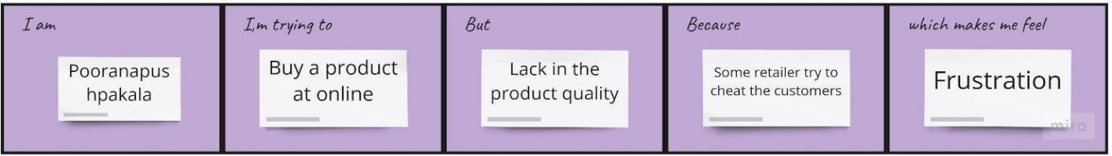**Problem statement 2:**

**Problem statement 3:**



**Problem statement 4:**

# PROJECT DESIGN

**PHASE 1**

* + 1. **PROPOSED SOLUTION**

|  |  |  |
| --- | --- | --- |
| S .No | Parameter | Description |
| 1. | Problem Statement | The problem faced by the retail store is they do not have any systematic system to record and keep their inventory data. It is difficult for the admin to record the inventory data quickly and safely because they only keep it in the logbook and not properly organized. |
| 2. | Solution description | The goal is to utilize the given data set about the Retail Store Stock Inventory and store the data in the cloud ,So the retail store can use this information to easily predict the inventory easily and quickly. |
| 3. | Novelty / Uniqueness | Complete a thorough analysis of our store; it leads to avoiding overstock and also analysis of the competitive relevant market. Gathering customer feedback and measuring our business results. |
| 4. | Social Impact / Customer Satisfaction | When customers get the products they want faster with fewer mistakes or out-of-stocks, it increases customer loyalty. |
| 5. | Business Model | Ad based Revenue model-  Awareness can be created for Optimize the use of inventory, reduce handling cost, optimize cash flow |
| 6. | Scalability of the Solution | Retail store stock inventory can be predicted easily with the data’s stored in the retail stores. It gives the best user experience and maintains the details |

* + 1. 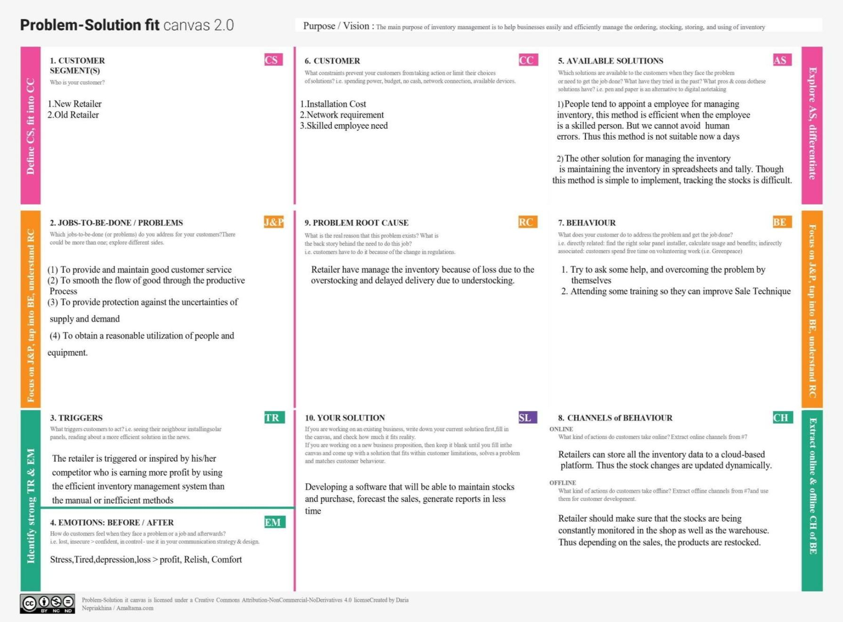**PROBLEM SOLUTION FIT**
    2. **SOLUTION ARCHITECTURE**

**Solution Architecture:**

Solution architecture is a complex process – with many sub-processes – that bridges the gap between business problems and technology solutions. Its goals are to:

* Find the best tech solution to solve existing business problems.
* Describe the structure, characteristics, behavior, and other aspects of the software to project stakeholders.
* Define features, development phases, and solution requirements.
* Provide specifications according to which the solution is defined, managed, and delivered.

**Example - Solution Architecture Diagram:**

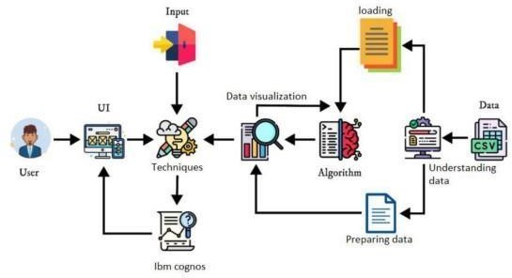

*Figure 1: Architecture and data flow of the voice patient diary sample application*

**Reference: [https://aws.amazon.com/blogs/industries/voice-applications-in-clinical-](https://aws.amazon.com/blogs/industries/voice-applications-in-clinical-research-powered-by-ai-on-aws-part-1-architecture-and-design-considerations/) [researchpowered-by-ai-o n-aws-part-1-architecture-and-design-considerations/](https://aws.amazon.com/blogs/industries/voice-applications-in-clinical-research-powered-by-ai-on-aws-part-1-architecture-and-design-considerations/)**

# PROJECT DESIGN PHASE 2

* + 1. **CUSTOMER JOURNEY MAP**

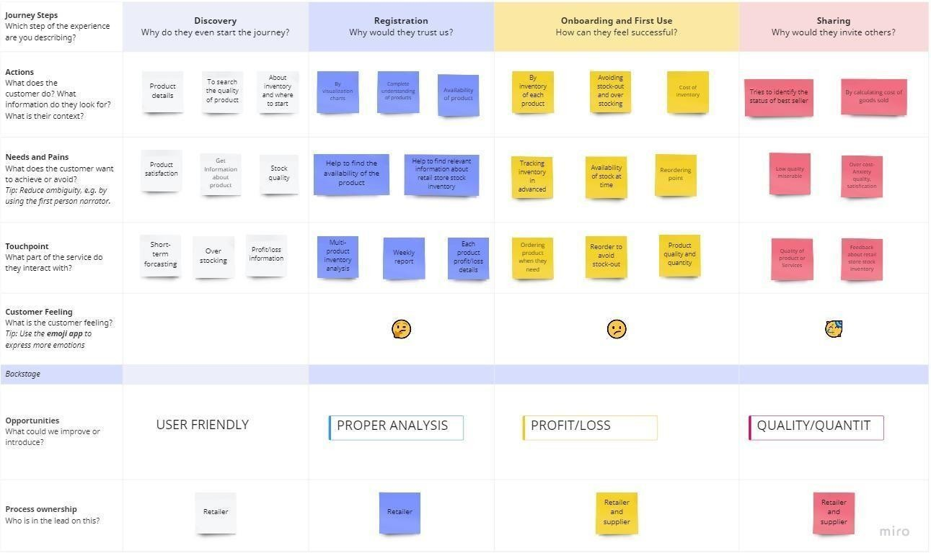

* + 1. **SOLUTION REQUIREMENTS**

Following are the functional/Solution requirements of the proposed solution.

|  |  |  |
| --- | --- | --- |
| **FR**  **No.** | **Functional Requirement (Epic)** | **Sub Requirement (Story / Sub-Task)** |
| FR- 1 | User Registration | Registration through Form Registration through Gmail |
| FR- 2 | User Confirmation | Confirmation via Email Confirmation via OTP |
| FR- 3 | User Login | Login with username Login with password |
| FR- 4 | Profile update | Update the user credentials Update the Contact details |
| FR- 5 | Uploading Data | Collect the customer details as well as product details  Upload the product details  This model predicts the best sold products and also it analysis the available stocks |
| FR-6 | Recommendation | User will request for Item  Get the Item recommendations |
| FR-7 | Ratings and Reviews | The user i.e retailer of any shop can give their ratings and view of this models |

**Non-functional Requirements:**

Following are the non-functional requirements of the proposed solution.

|  |  |  |
| --- | --- | --- |
| **FR**  **No.** | **Non-Functional Requirement** | **Description** |
| NFR-  1 | **Usability** | They are more likely to have enough inventory to capture every possible sale while avoiding overstock and  minimizing expenses. |
| NFR-  2 | **Security** | This can be used only by the users who have their proper login credentials |
| NFR-  3 | **Reliability** | Avoid over or understocking Ensure accurate inventory valuation Prevent order delays  Reduce dead stock |
| NFR-  4 | **Performance** | From this, the model can predict the dead stocks and highly profitable stocks. The accuracy of this model will  be ensured by checking multiple times. |
| NFR-  5 | **Availability** | This model is suitable for all kinds of retail stores. It can give retailers real- time visibility into stock levels,avoid stockouts, keep inventory carrying  costs low and help meet customer expectations |
| NFR-  6 | **Scalability** | More users can be accessed at the same time without any issues. The feedback of the users will be taken and be proceeded further up to the satisfaction of the user. |

* + 1. **DATA FLOW DIAGRAM**

**Data Flow Diagram:**

A Data Flow Diagram (DFD) is a traditional visual representation of the information flows within a system. A neat and clear DFD can depict the right amount of the system requirement graphically. It shows how data enters and leaves the system, what changes the information, and where data is stored.

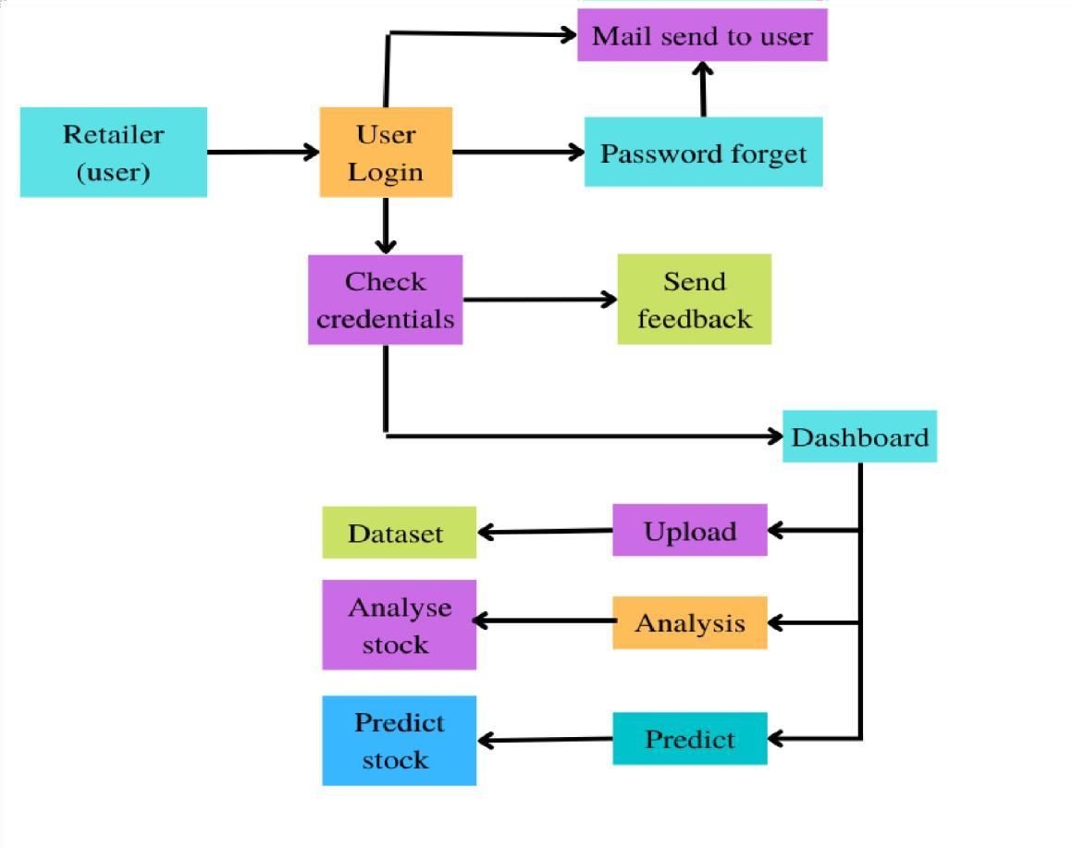

|  |  |  |  |  |  |  |
| --- | --- | --- | --- | --- | --- | --- |
| **User Type** | **Functional Requirement (Epic)** | **User Story Number** | **User Story / Task** | **Acceptance criteria** | **Priority** | **Release** |
| Customer (Mobile user) | Registration | USN-1 | As a user, I can register for the web application by entering my email, password, and confirming my password. | I can access my account / dashboard | High | Sprint-1 |
|  |  | USN-2 | As a user, after completing the registration I will receive confirmation email once I have registered for the web application | I can receive confirmation email & click confirm | High | Sprint-1 |
|  |  | USN-3 | As a user, I can register for the web application through LinkedIn | I can register & access the dashboard with LinkedIn Login | Low | Sprint-2 |
|  |  | USN-4 | As a user, I can register for the web application through Google account | I can register & access the dashboard with Gmail login | Medium | Sprint-1 |
|  | Login | USN-5 | As a user, I can log into the application by entering email & password after installing the web application | I can access the dashboard by login into the application | High | Sprint-1 |
|  | Dashboard | USN-6 | As a user, I can view the charts and graphs representation of the dataset and the information shown in the dashboard | I can analyse the stocks in my retail store. | High | Sprint-1 |
| Customer (Web user) |  | USN-1 | As a user, I can register for the web application entering my email, password,confirming my password. | I can access my account / dashboard | High | Sprint-1 |
| Customer Care Executive |  | USN-2 | As a user, after completing the registration I will receive confirmation email once I have registered for the web application | I can receive confirmation email & click confirm | High | Sprint-1 |

|  |  |  |  |  |  |  |
| --- | --- | --- | --- | --- | --- | --- |
| **User Type** | **Functional Requirement (Epic)** | **User Story Number** | **User Story / Task** | **Acceptance criteria** | **Priority** | **Release** |
| Administrator |  | USN-3 | As a user, I can register for the web application through LinkedIn | I can register & access the dashboard with LinkedIn Login | Low | Sprint-2 |
|  |  | USN-4 | As a user, I can register for the web application through Google account | I can register & access the dashboard with Gmail login | Medium | Sprint-1 |
|  | Login | USN-5 | As a user, I can log into the web application  by entering email & password after installing the application. | I can access the dashboard by login into the application | High | Sprint-1 |
|  | Dashboard | USN-6 | As a user, I can view the charts and graphs representation of the dataset and the information shown in the dashboard. | I can analyse the stocks in my retail store. | High | Sprint-1 |
| Customer Care Executive |  | CCE-1 | As a customer care executive, I will always be available for the interaction with the customer to clarify the queries. | An executive will analyse the customer complaints, rectify their problems | High | Sprint-2 |
| Administrator |  | ADMIN-1 | As an administrator, I will manage backup and recovery, data modelling and design, distributed computing, database system, and a data security | Administrator can evaluate, design, review and implementing a data,they are also responsible for updating and maintaining the data. | High | Sprint-2 |

* + 1. **TECHNOLOGY STACK**

**Technical Architecture:**

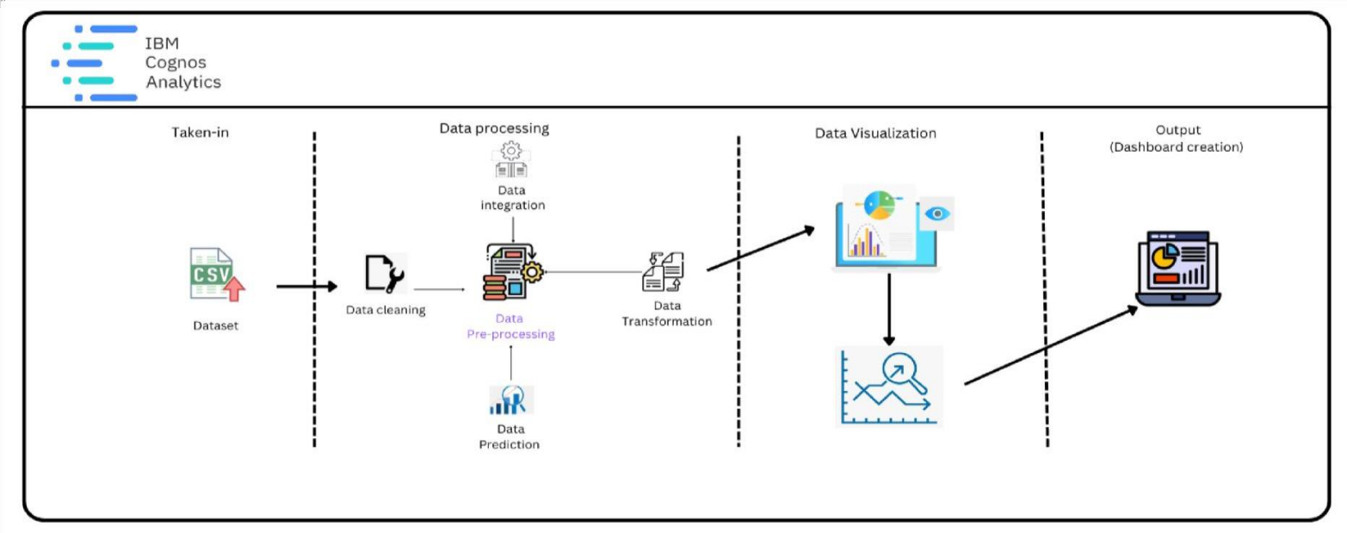

**Table-1 : Components & Technologies:**

|  |  |  |  |
| --- | --- | --- | --- |
| **S.No** | **Component** | **Description** | **Technology** |
| 1. | User Interface | The user interacts with application using Web UI | HTML, CSS,  JavaScript |
| 2. | Data Processing | The data from the dataset is pre- processed | IBM  Cognos Analytics |
| 3. | Cloud Database | The clean dataset is stored on IBM Cloud | IBM Cloud |
| 4. | Data visualization | The data is visualized into different forms | IBM  Cognos Analytics,  Python |
| 5. | Prediction | These Algorithm techniques are used to predict the proper way to make the stock in store. | ML  algorithms – Logistic Regression, Linear Regression, Random  Forest,ABC. |

**Table-2: Application Characteristics:**

|  |  |  |  |
| --- | --- | --- | --- |
| **S.No** | **Characteristics** | **Description** | **Technology** |
| 1. | Open-Source Frameworks | Open-source frameworks used | IBM  Cognos  Analytics, Python |
| 2. | Security Implementations | Request authentication using Encryptions | Encryptions |
| 3. | Scalable Architecture | Scalability consists of 3-tiers | Web Server  – HTML, CSS,  Javascript Application Server – Python Database Server –  IBM Cloud |
| 4. | Availability | The application is available for cloud users | IBM Cloud Hosting |
| 5. | Performance | The user can know how to maintain the inventory to increase profits. | ML  algorithms |

# Project planning phase

* + 1. **PREPARE MILESTONE AND ACTIVITY LIST**

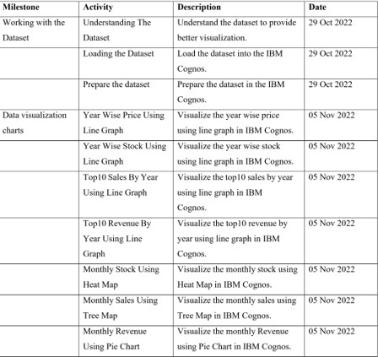

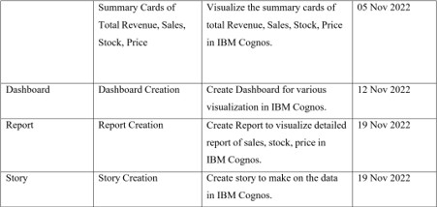

* + 1. **SPRINT DELIVERY PLAN**

## Product backlogs, Sprint schedule, Estimation(4 marks)

|  |  |  |  |  |  |  |
| --- | --- | --- | --- | --- | --- | --- |
| **Sprint** | **Functional Requirement (Epic)** | **User Story Number** | **User Story / Task** | **Story Points** | **Priority** | **Team Members** |
| Sprint-1 | Data Collection | USN-1 | The dataset is collected and the understanding of dataset is done to  present the analytics to the user | 2 | High | Pavithra M Pooranapushpakala M Smiwin Gems  Suriya Lakshmi A |
| Sprint-1 | Data Preparation | USN-2 | As a user, I can view the accurate analytics of data by prepared data. The data preparation is done to restructure  and clean the data. | 3 | High | Pavithra M Pooranapushpakala M Smiwin Gems  Suriya Lakshmi A |
| Sprint-2 | Data Exploration | USN-3 | As a user, I can view the visualized data to get the better understanding about the sales, stock, revenue and price. | 8 | High | Pavithra M Pooranapushpakala M Smiwin Gems  Suriya Lakshmi A |
| Sprint-3 | Dashboard Creation | USN-4 | As a user, I can view the different visualization in the dashboard about the  sales, stock, revenue and price. | 8 | High | Pavithra M Pooranapushpakala M Smiwin Gems  Suriya Lakshmi A |

|  |  |  |  |  |  |  |
| --- | --- | --- | --- | --- | --- | --- |
| **Sprint** | **Functional Requirement (Epic)** | **User Story Number** | **User Story / Task** | **Story Points** | **Priority** | **Team Members** |
| Sprint-4 | Report creation | USN-5 | As a user, I can view the detailed report of the sales, stock, revenue and price. The user can get the report of  the particular data. | 8 | High | Pavithra M Pooranapushpakala M  Smiwin Gems Suriya Lakshmi A |
| Sprint-4 | Story creation | USN-6 | As a user, I can view the story to get the better understanding of the sales, stock, revenue and price. The user can make  decisions based on the story. | 8 | High | Pavithra M Pooranapushpakala M  Smiwin Gems Suriya Lakshmi A |

Project Tracker, Velocity & Burndown Chart: (4 Marks)

|  |  |  |  |  |  |  |
| --- | --- | --- | --- | --- | --- | --- |
| **Sprint** | **Total Story Points** | **Duration** | **Sprint Start Date** | **Sprint End Date (Planned)** | **Story Points Completed (as on**  **Planned End Date)** | **Sprint Release Date (Actual)** |
| Sprint-1 | 5 | 6 Days | 24 Oct 2022 | 29 Oct 2022 | 5 | 29 Oct  2022 |
| Sprint-2 | 8 | 6 Days | 31 Oct 2022 | 05 Nov 2022 | 8 | 05 Nov  2022 |
| Sprint-3 | 8 | 6 Days | 07 Nov 2022 | 12 Nov 2022 | 8 | 12 Nov  2022 |
| Sprint-4 | 16 | 6 Days | 14 Nov 2022 | 19 Nov 2022 | 16 | 19 Nov  2022 |

Velocity:

Imagine we have a 10-day sprint duration, and the velocity of the team is 20 (points per sprint). Let’s calculate the team’s average velocity (AV) per iteration unit (story points per day)

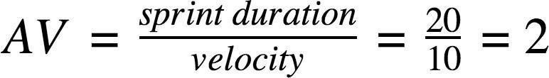

|  |  |  |  |
| --- | --- | --- | --- |
| **Sprint** | **Story points** | **Duration** | **Average velocity** |
| **Sprint-1** | 5 | 6 | 0.83 |
| **Sprint-2** | 8 | 6 | 1.33 |
| **Sprint-3** | 8 | 6 | 1.33 |
| **Sprint-4** | 16 | 6 | 2.66 |
| **Total** | 37 | 24 | 1.54 |

**Jira project planning:**

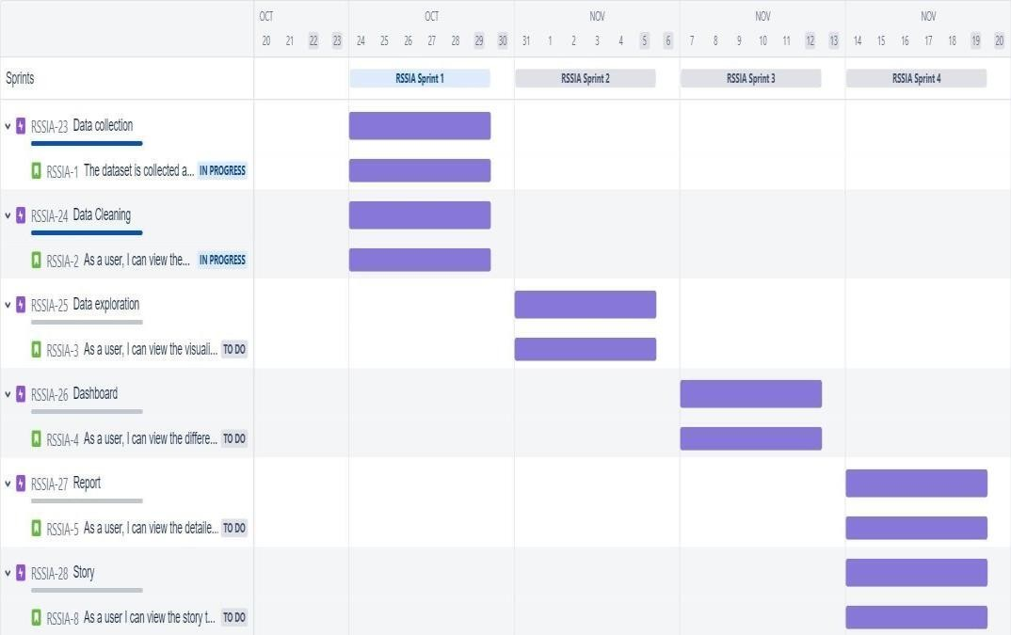

**Burndown Chart:**

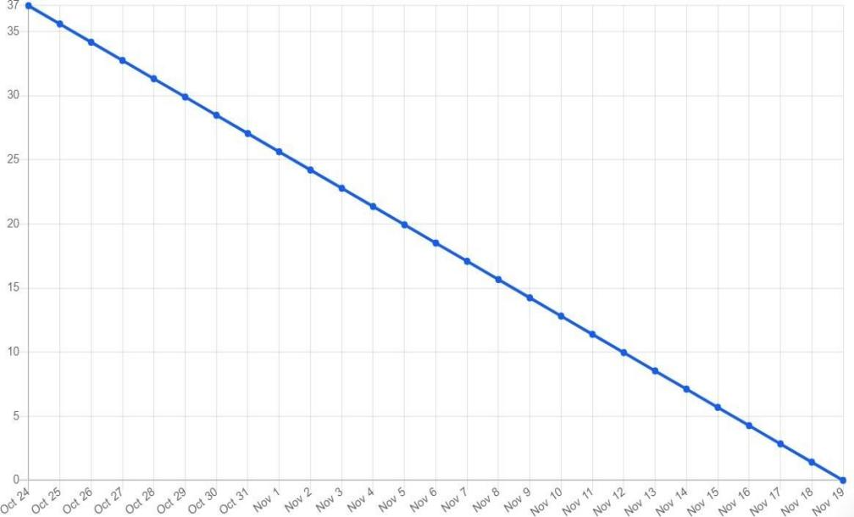

**Sprint 1:**

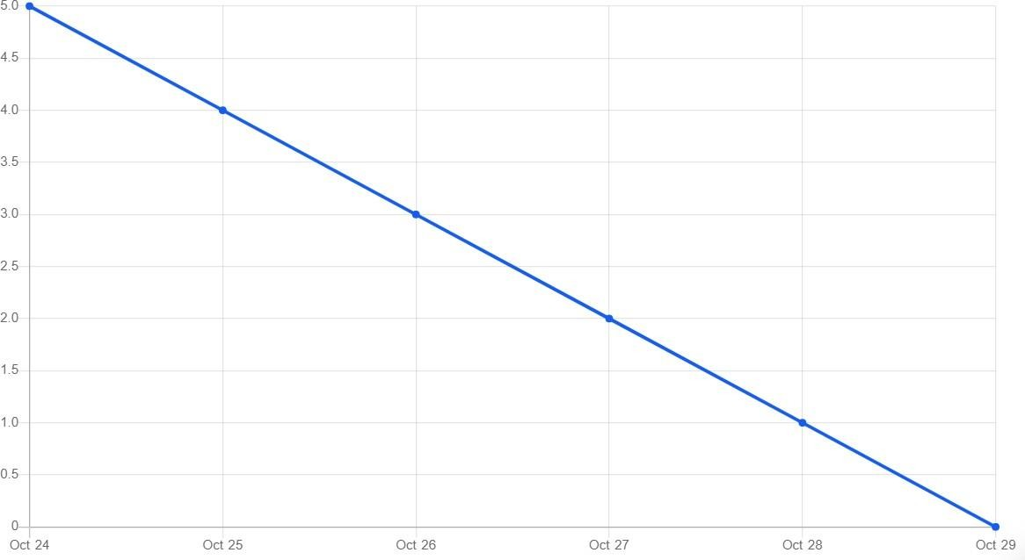

**Sprint 2:**

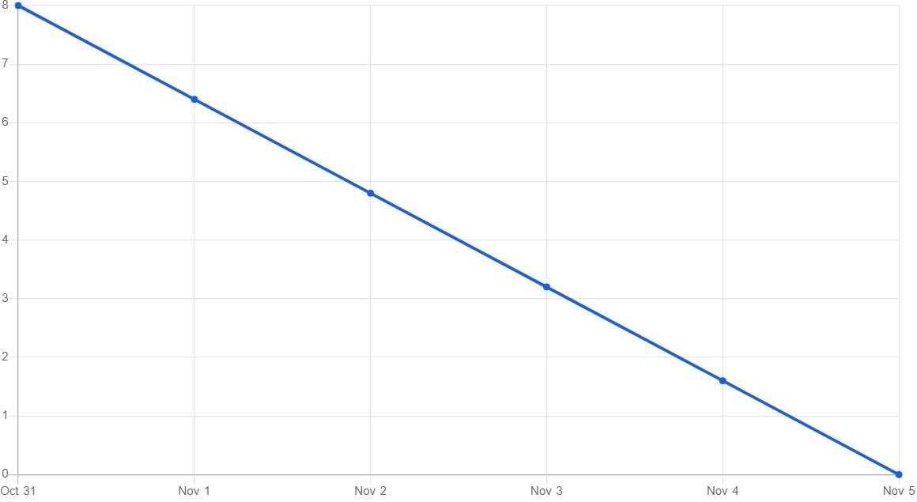

**Sprint 3:**

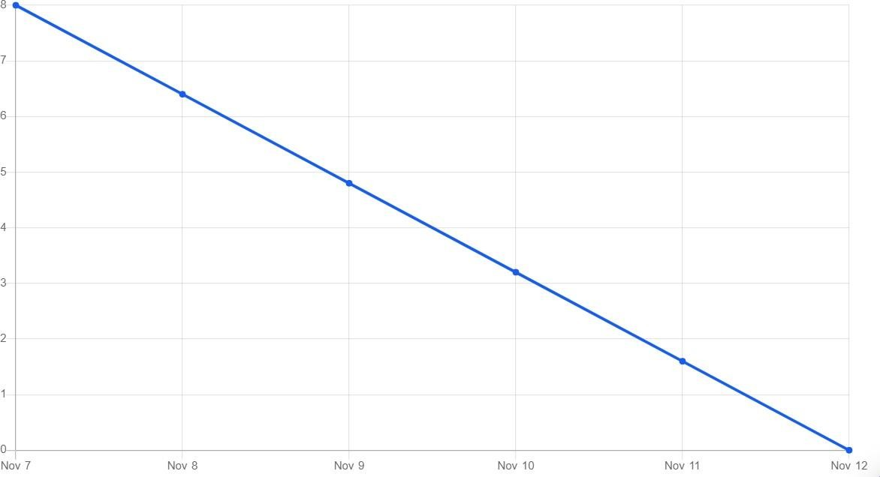

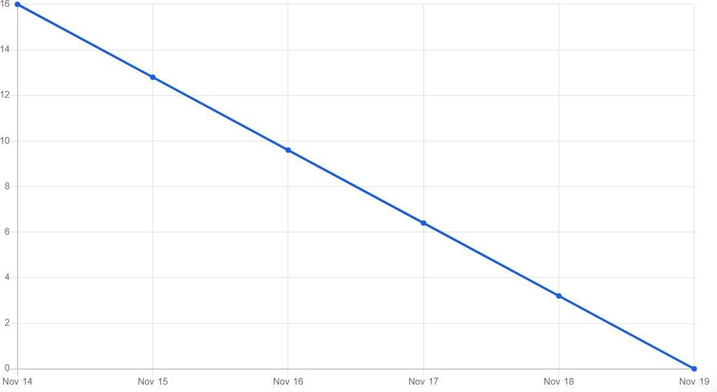**Sprint 4:**

34

# 7.PROJECT DEVELOPMENT

**PHASE**

* 1. **DELIVERY OF SPRINT 1**

**Project Development Phase:**

**Sprint-1:**

* Data Collection ➢ Data Preparation **Sprint-2:**
* Data Exploration **Sprint-3:**
* Dashboard Creation **Sprint-4:**
* Report Creation
* Story Creation

**Sprint-1:**

**Data Collection:**

Download the Dataset

Dataset link - https://drive.google.com/drive/folders/1kiL- 5CHJmQvbk9VyFsuUs-myAupBZGNy

**Load the Dataset:**

Tool used – IBM Cognos

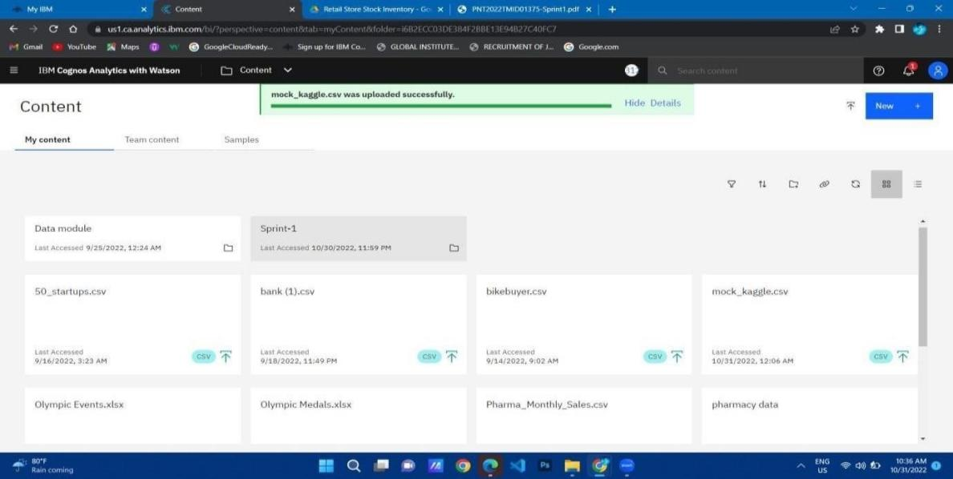

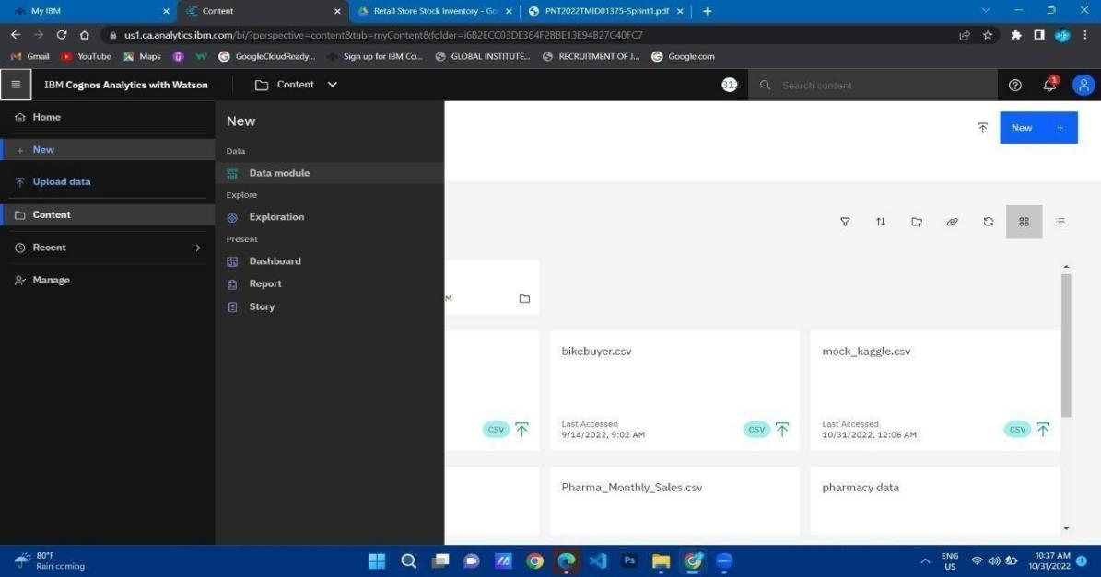

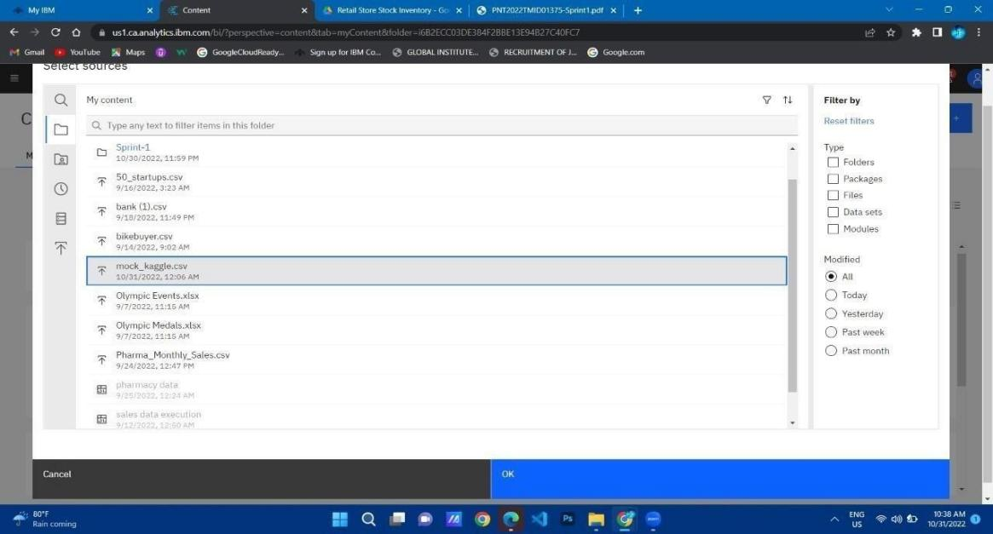

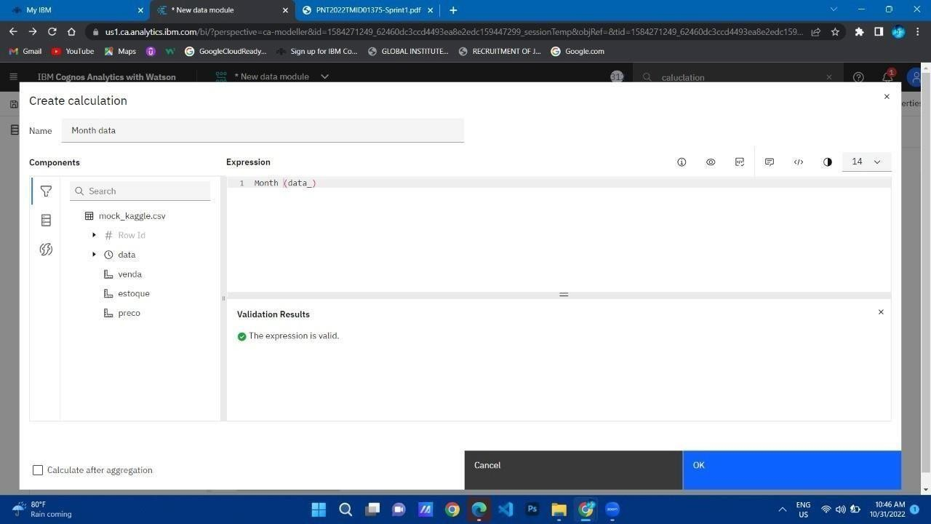**Month Data**

38

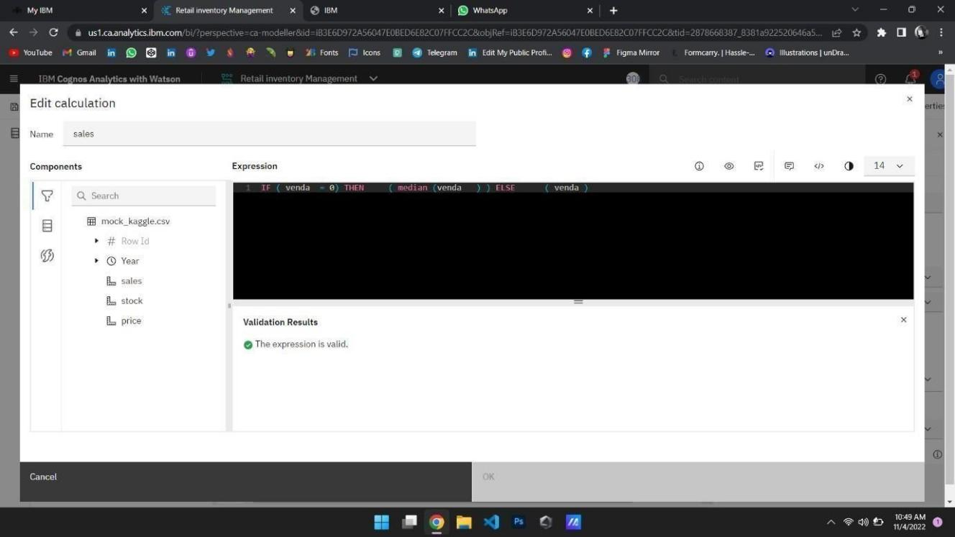

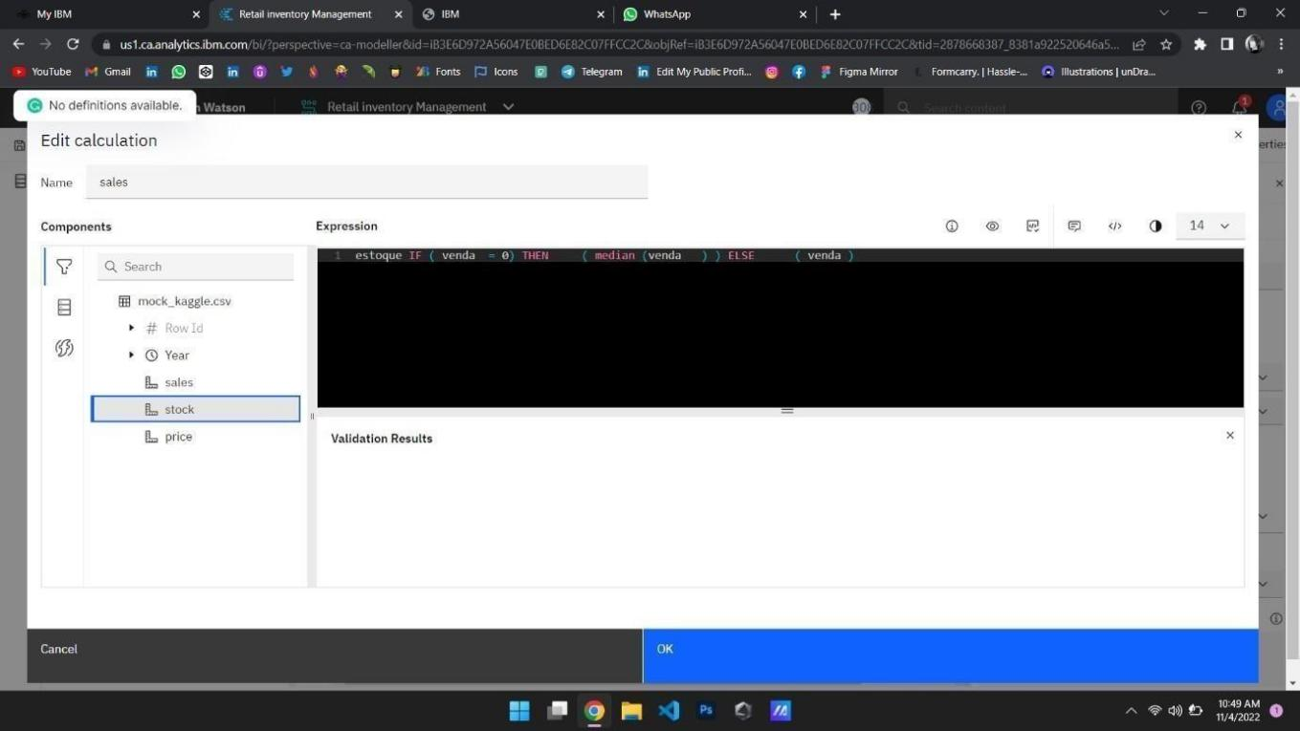

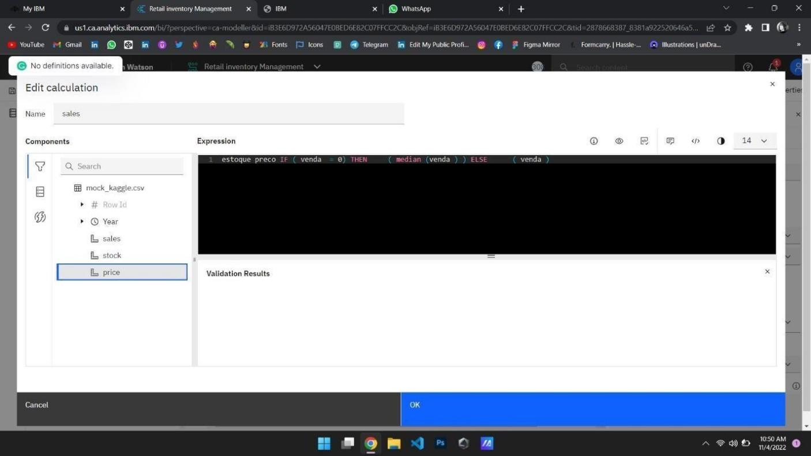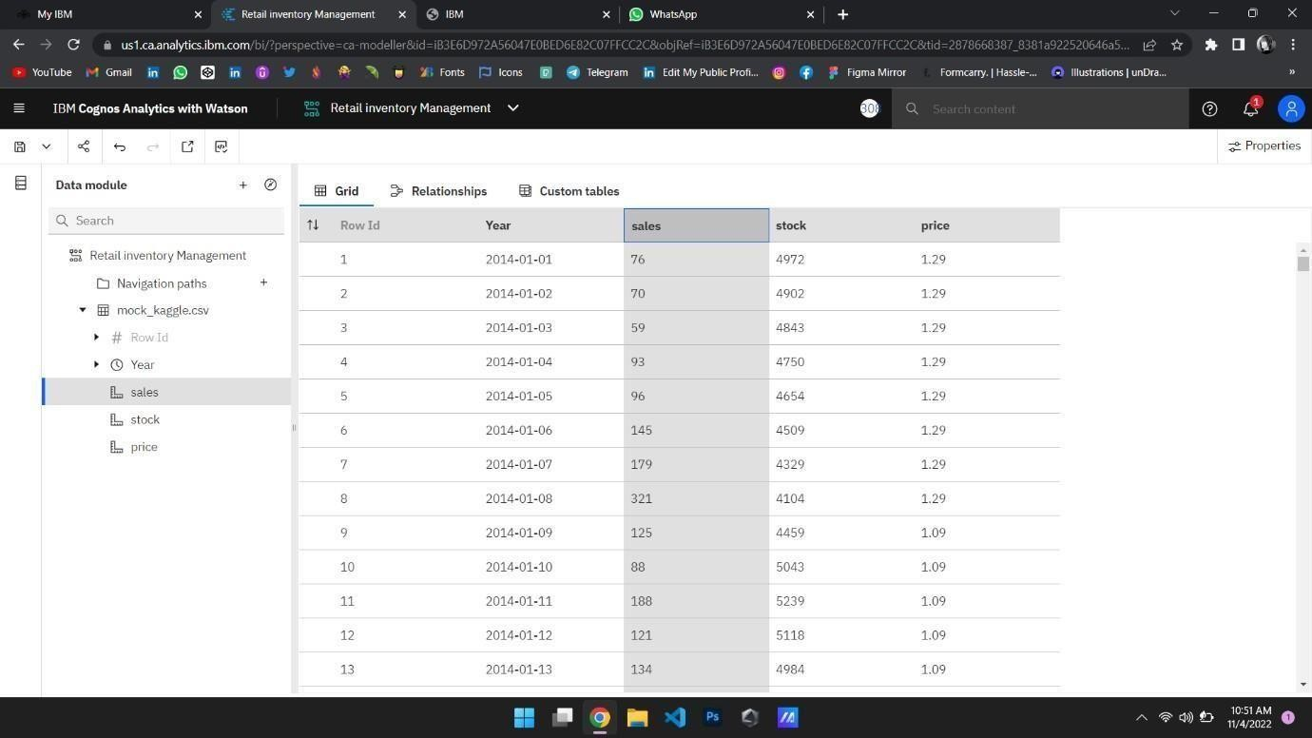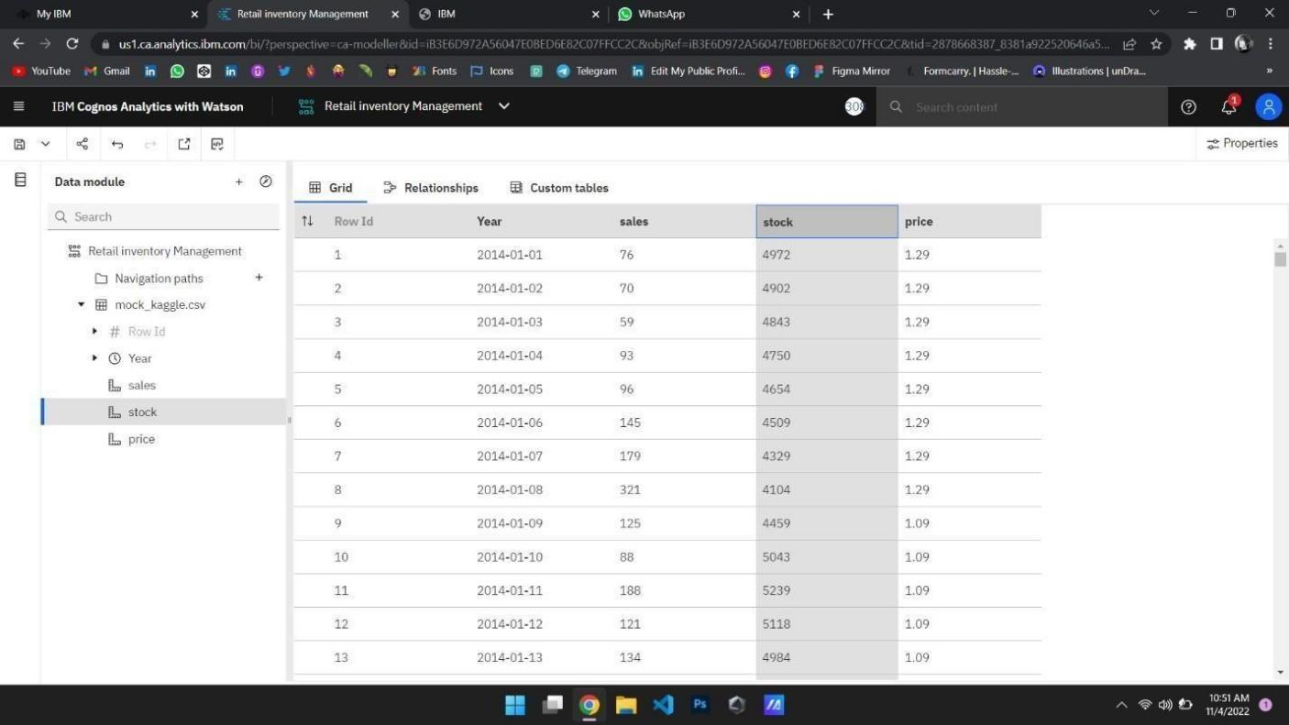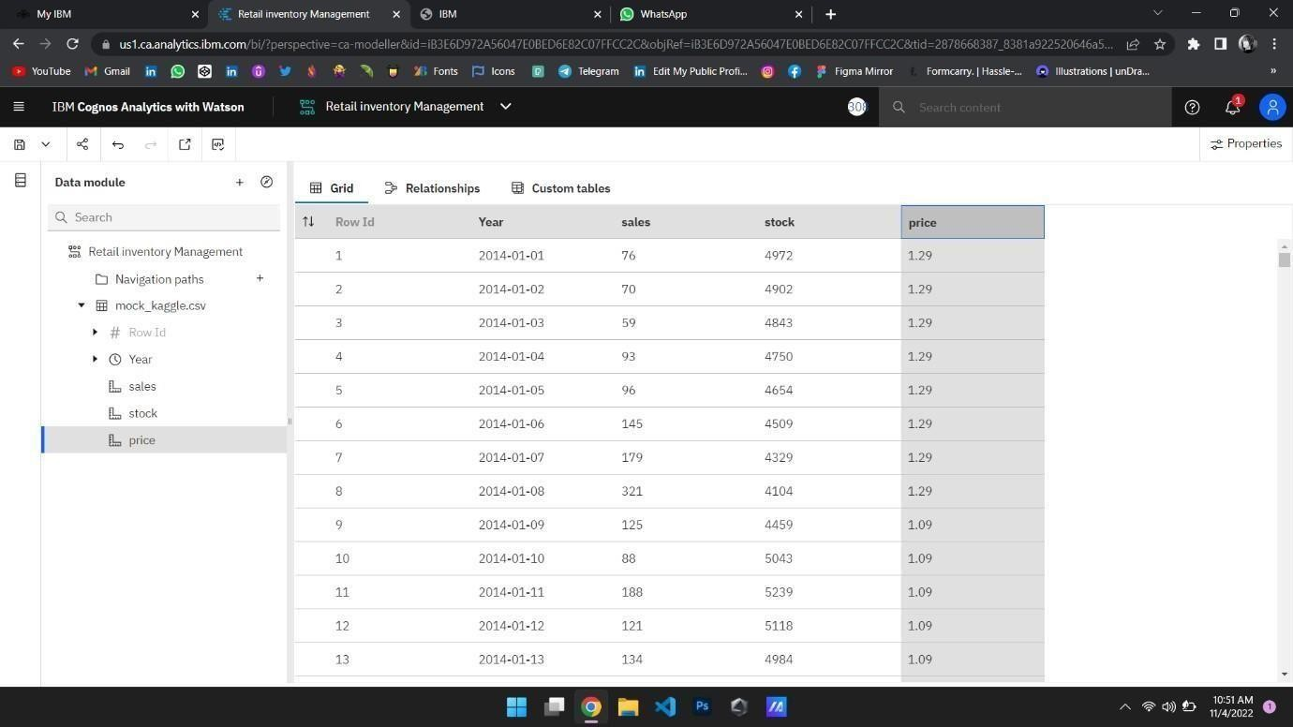

**Stock format Data:**

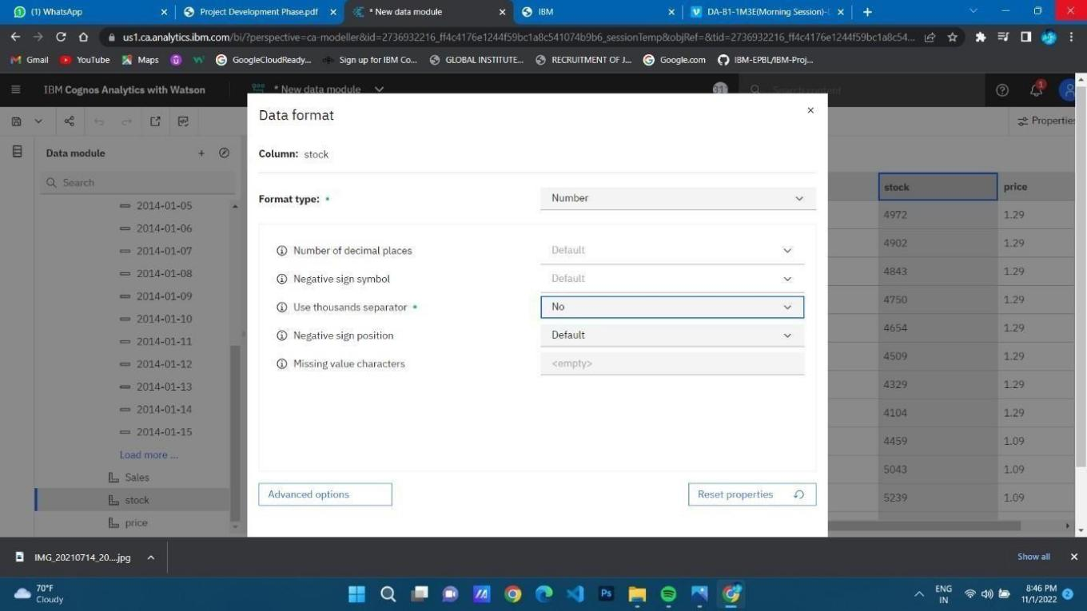

**Sales Format Data:**

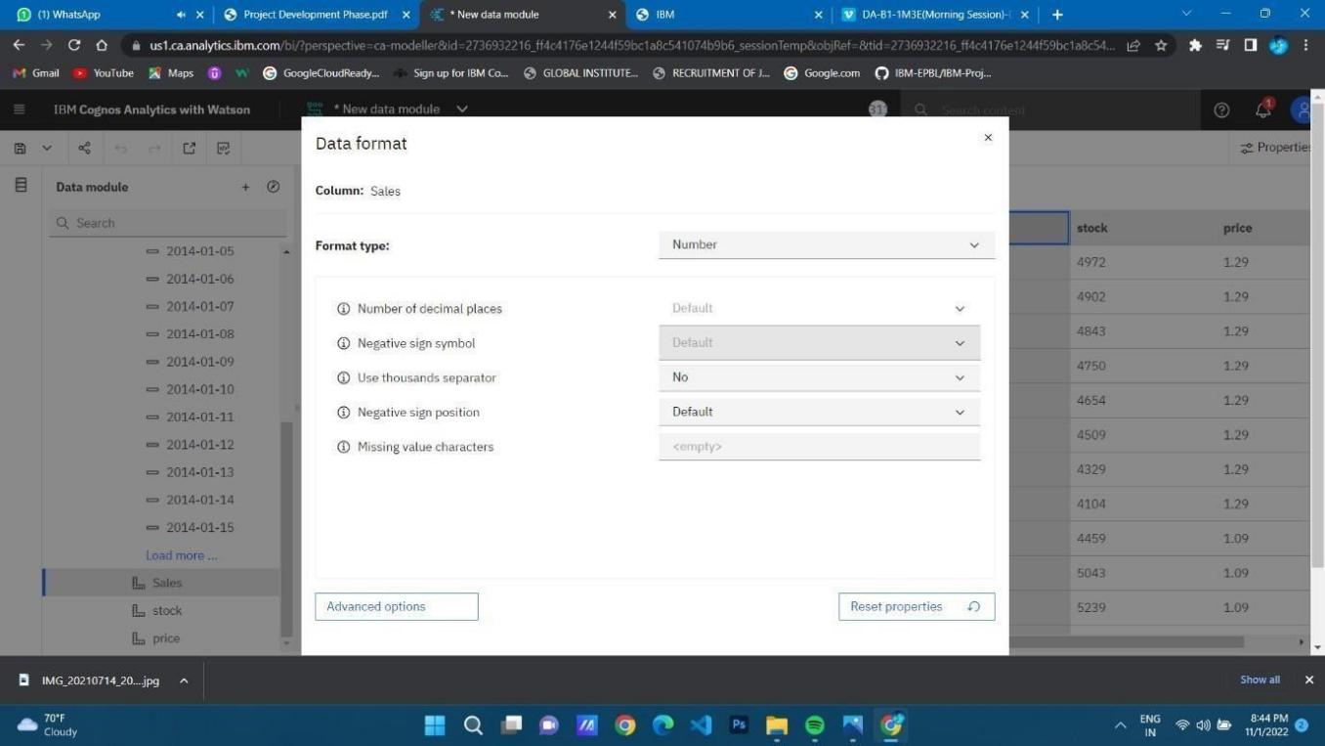

**Price Format data:**

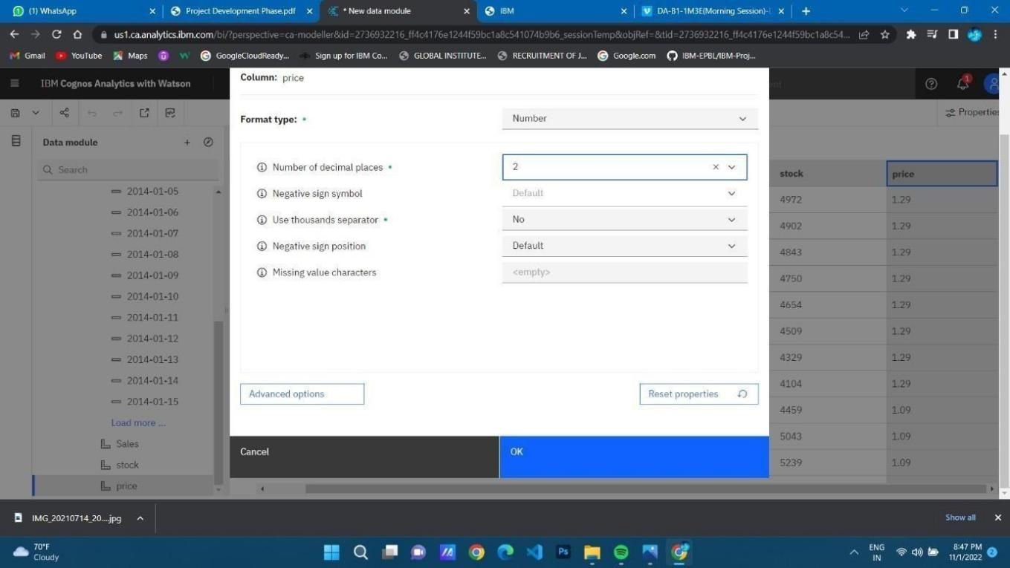

**Revenue format data:**

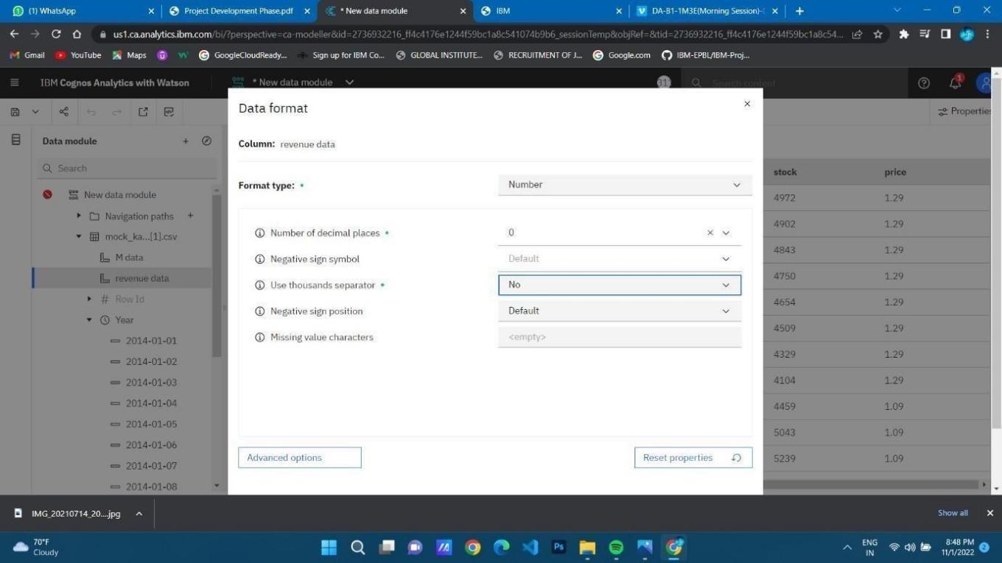

* 1. **DELIVERY OF SPRINT 2**

**SPRINT-2:**

**DATA EXPLORATION**

* + LOAD THE DATASET
  + SALES ANALYSIS
  + PRICE ANALYSIS
  + STOCK AND PRICE FOR YEAR COLORED BY PRICE PRICE FOR YEAR COLORED BY YEAR
  + STOCK AND SALES FOR YEAR COLORED BY YEAR
  + YEAR COLORED BY YEAR SIZED BY STOCK
  + STOCK TREE SUNBURST
  + SALES TO PRICE WITH LINE WIDTH PRICE
  + STOCK USERS
  + YEAR SIZED BY SALES
  + PREPARED DATA LINK

**DATA COLLECTION:**

Download the Dataset

Dataset link - https://drive.google.com/drive/folders/1kiL5CHJmQvbk9VyFsuUs

-myAupBZGNy

**LOAD THE DATASET:**

Tool used – IBM Cognos

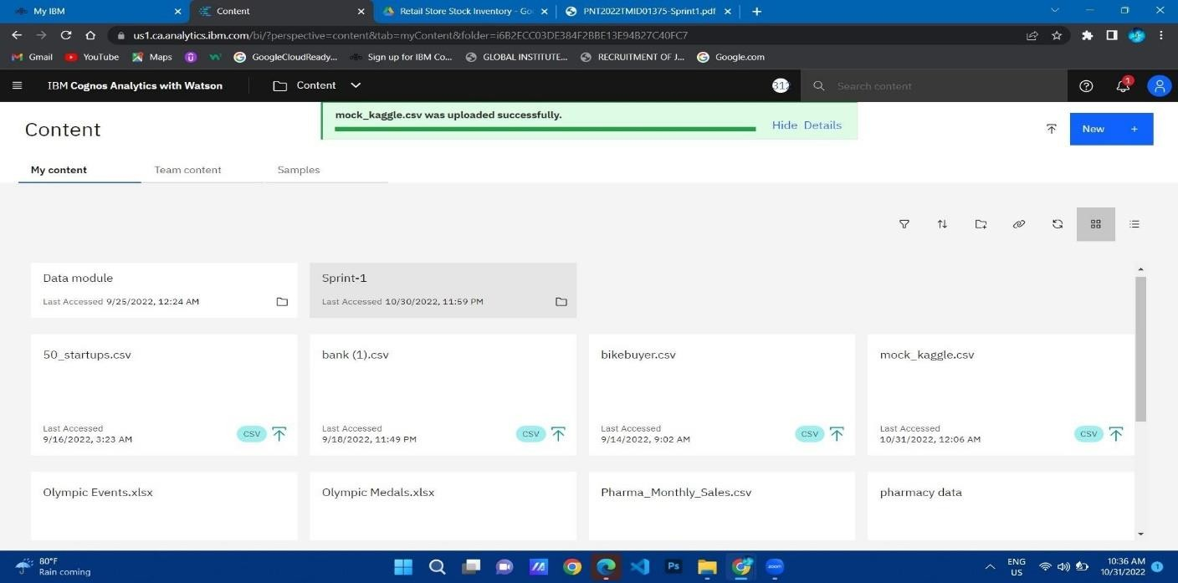

SALES ANALYSIS:

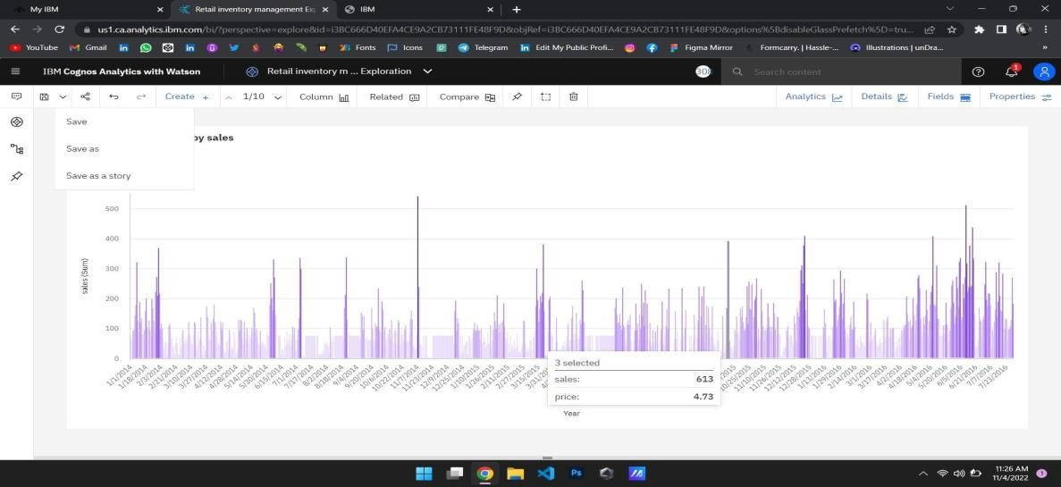

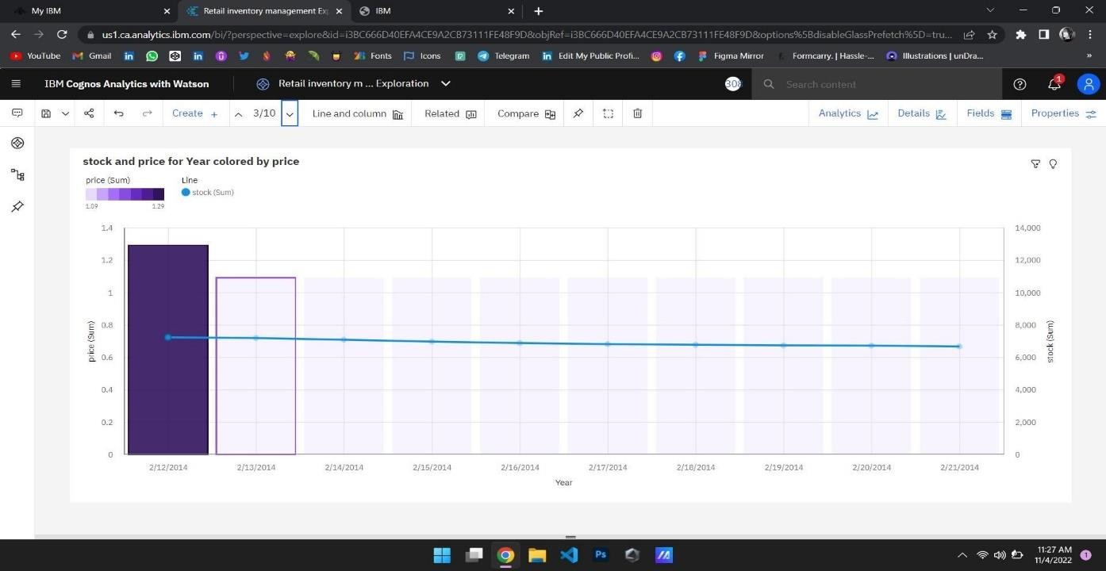**PRICE ANALYSIS:**

**STOCK AND PRICE FOR YEAR COLORED BY PRICE:**

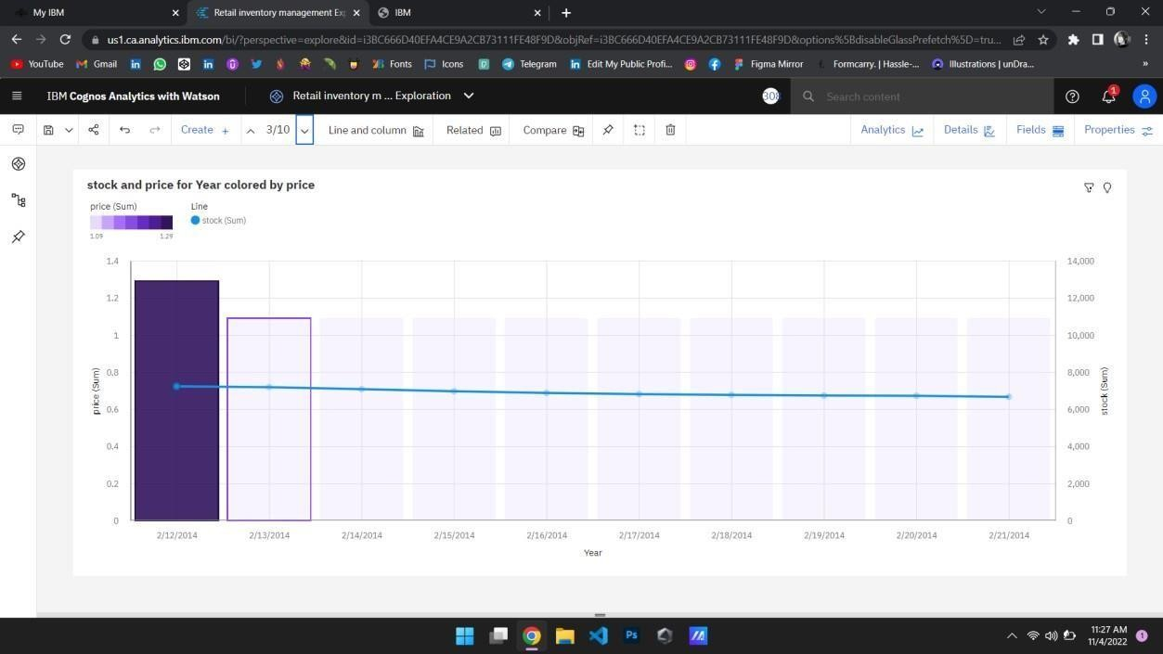

**PRICE FOR YEAR COLORED BY YEAR:**

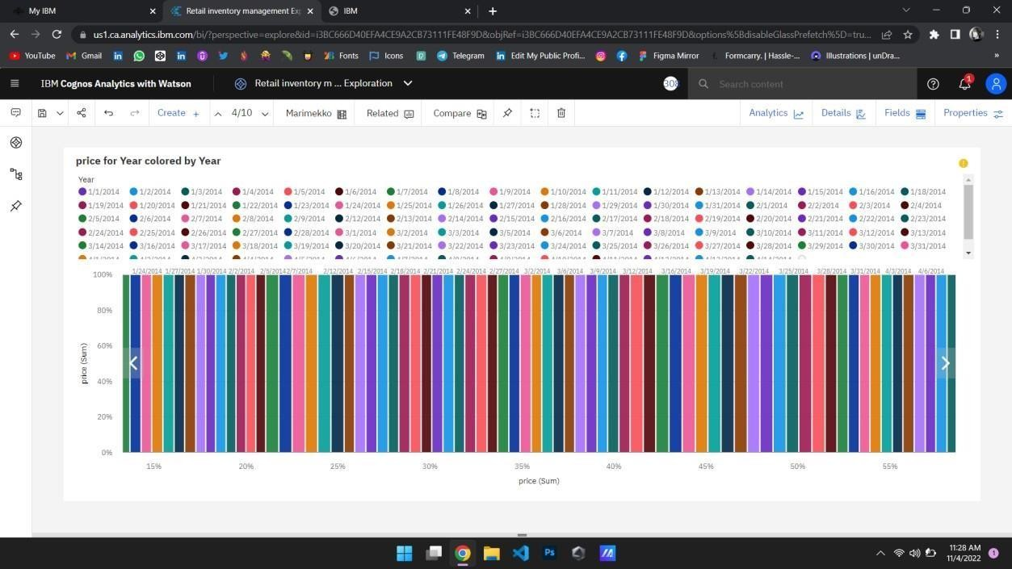

**STOCK AND SALES FOR YEAR COLORED BY YEAR:**

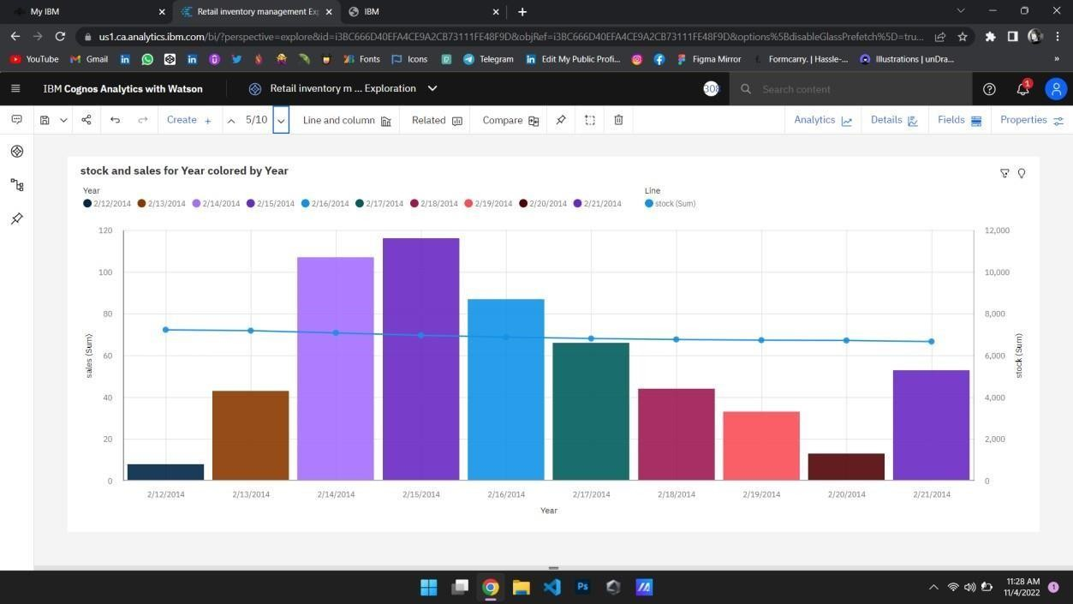

**YEAR COLORED BY YEAR SIZED BY STOCK:**

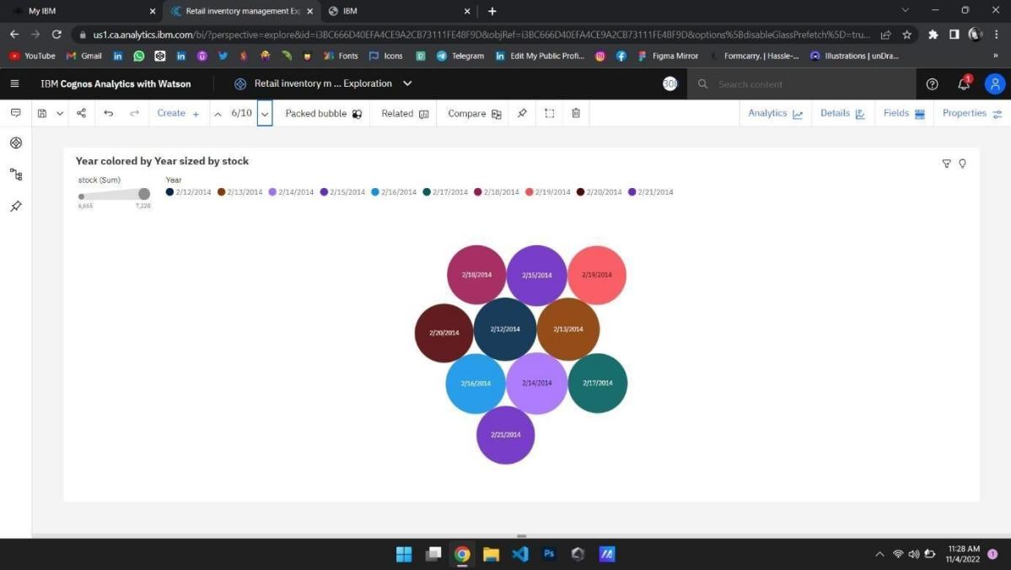

**STOCK TREE SUNBURST:**

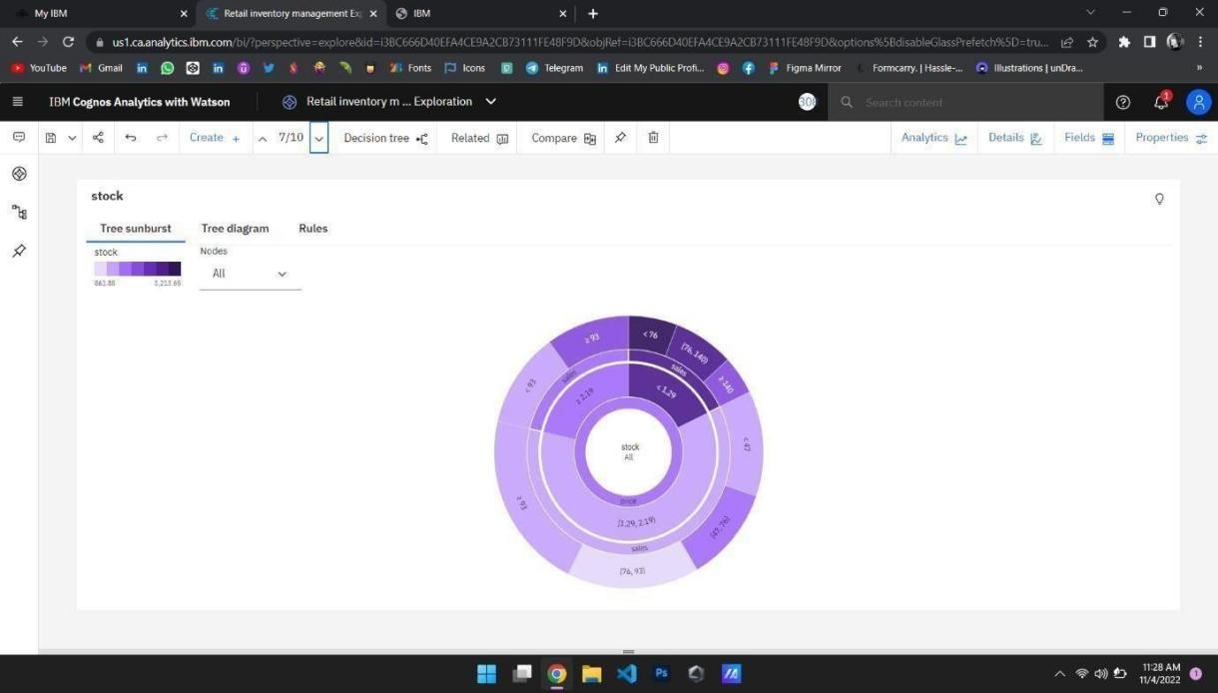

**SALES TO PRICE WITH LINE WIDTH PRICE:**

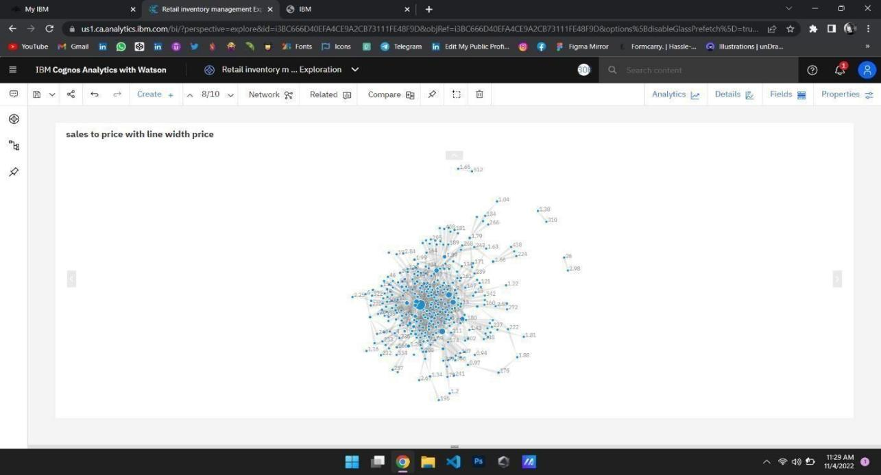

**STOCK USERS:**

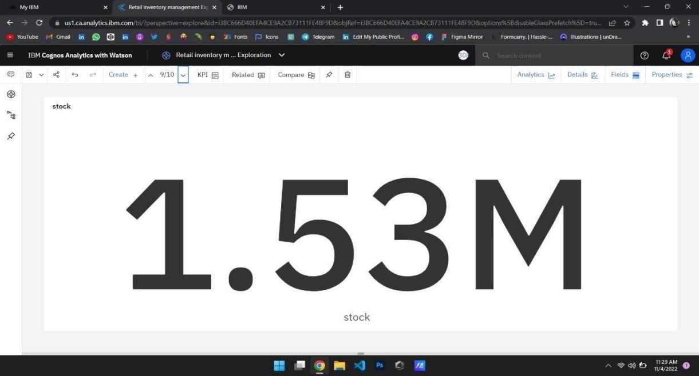

**YEAR SIZED BY SALES:**

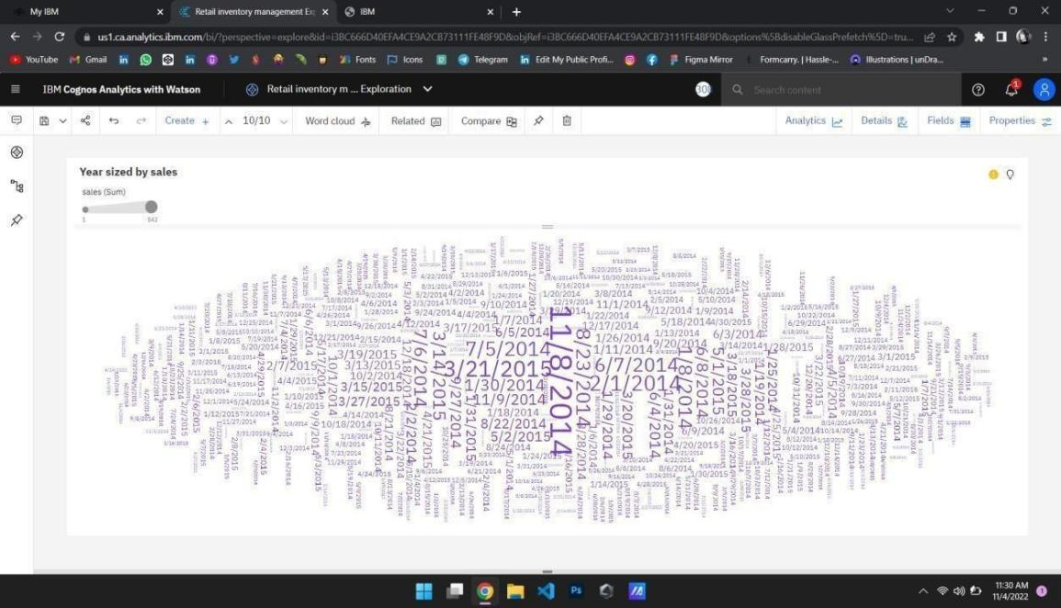

* 1. **DELIVERY OF SPRINT 3**

Dashboard Creation:

Sales by Year Line Chart

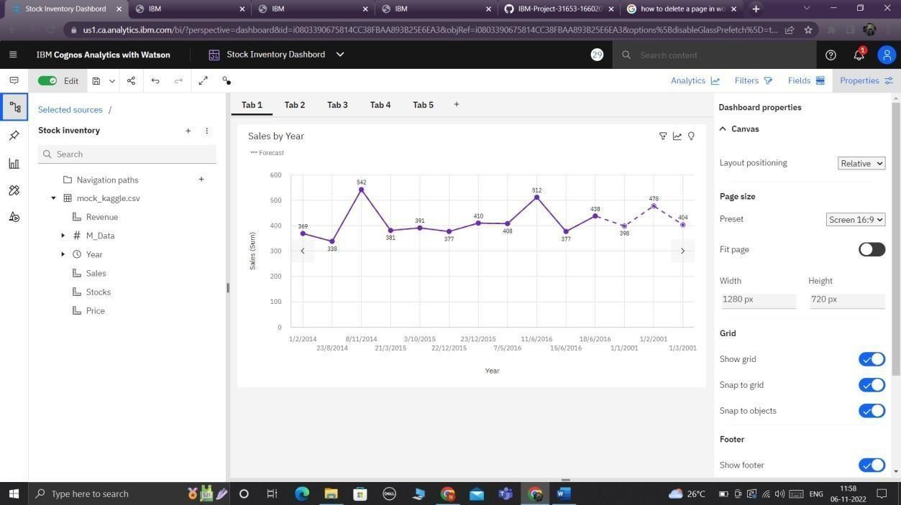

Stock by Year a Line Visual

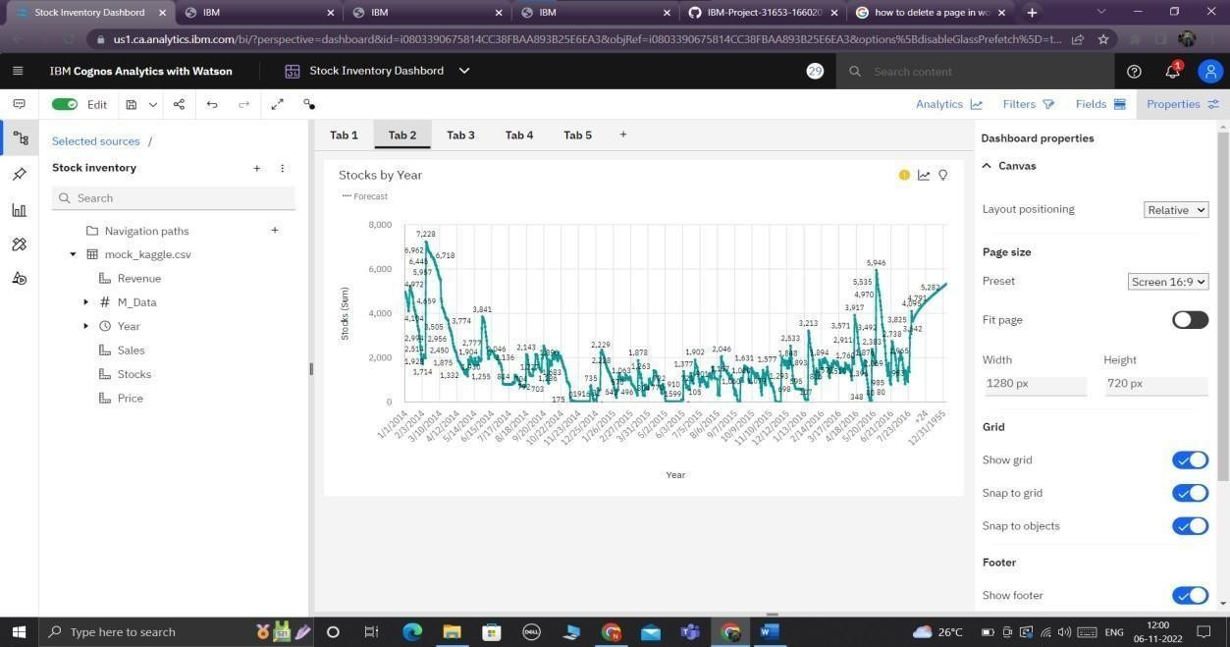

Price by Year Line visual

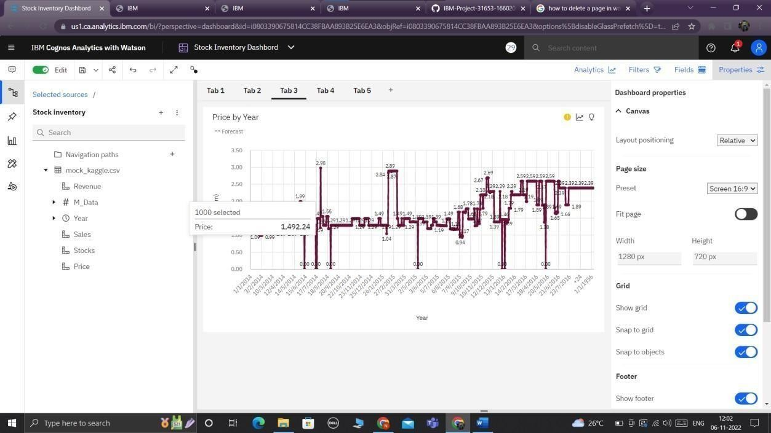

Revenue by Year Column Forecast visual.

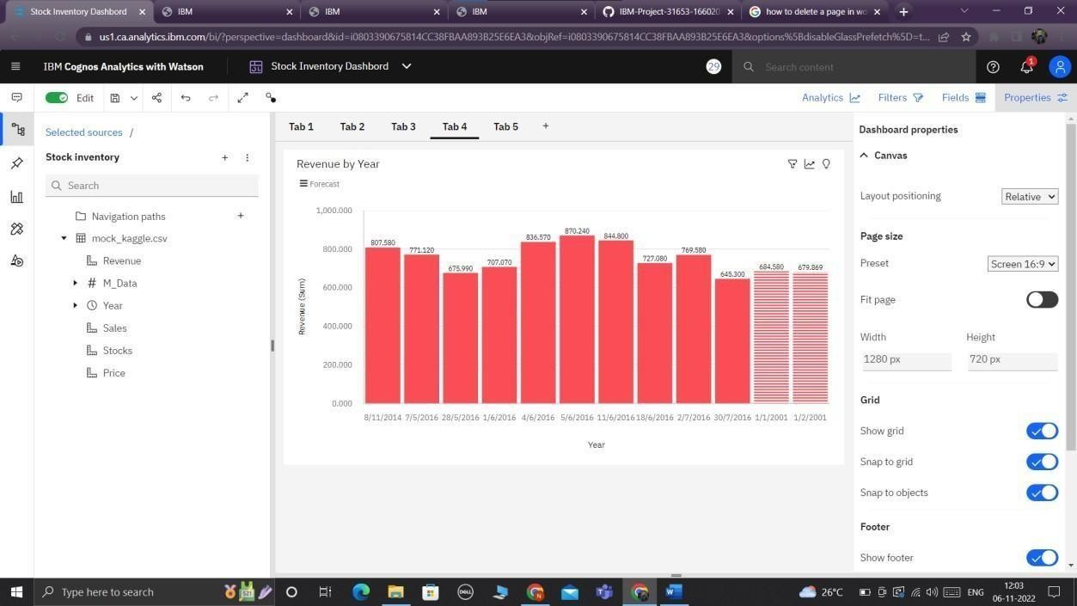

Dashboard creation.

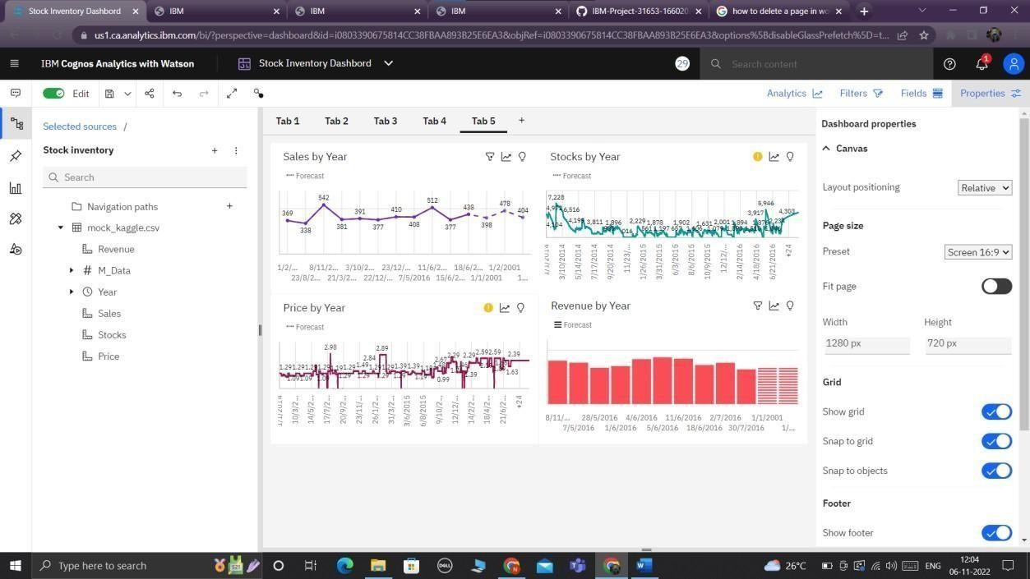

Dashboard:

Stock inventory dashboard

1. Forecast by years:

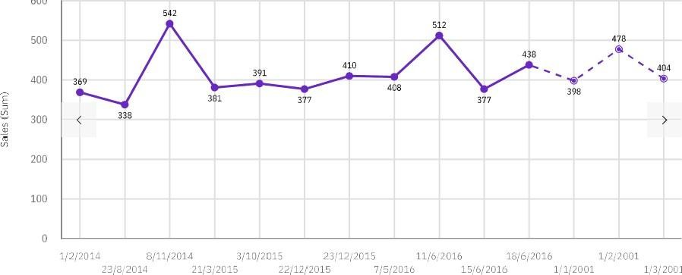

600

2c•ü1

1. Stocks by years:

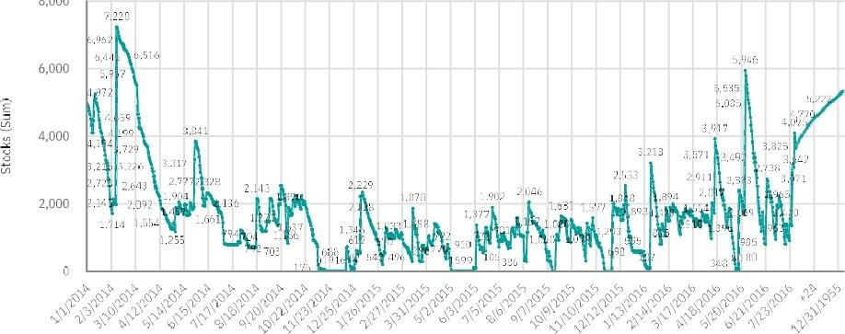

8,000

1. Price by years:

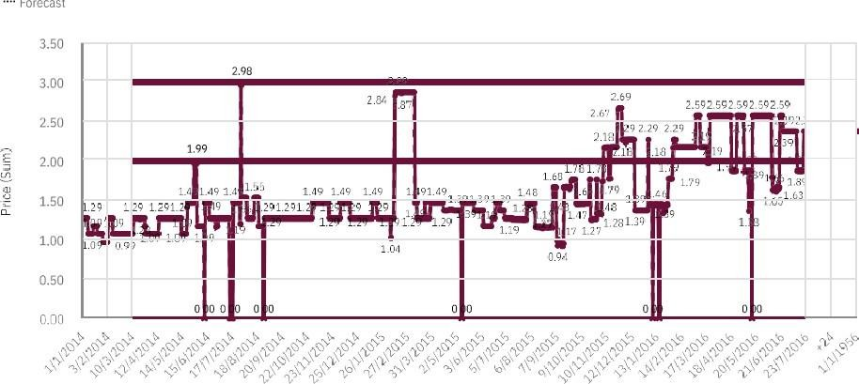

Forecast

1. Revenue by year:

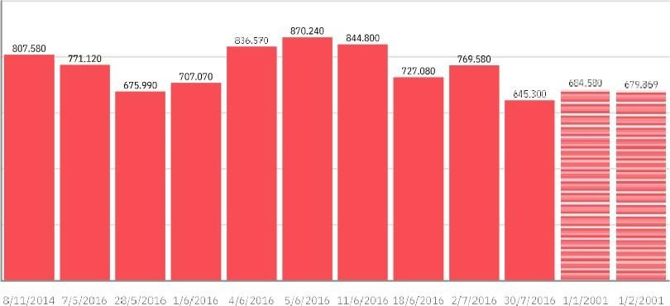1,000.000

aoa.coo

600 coo

aoo.coo

200.000

0.000

* 1. **DELIVERY OF SPRINT 4**

Retail store stock inventory analytics report

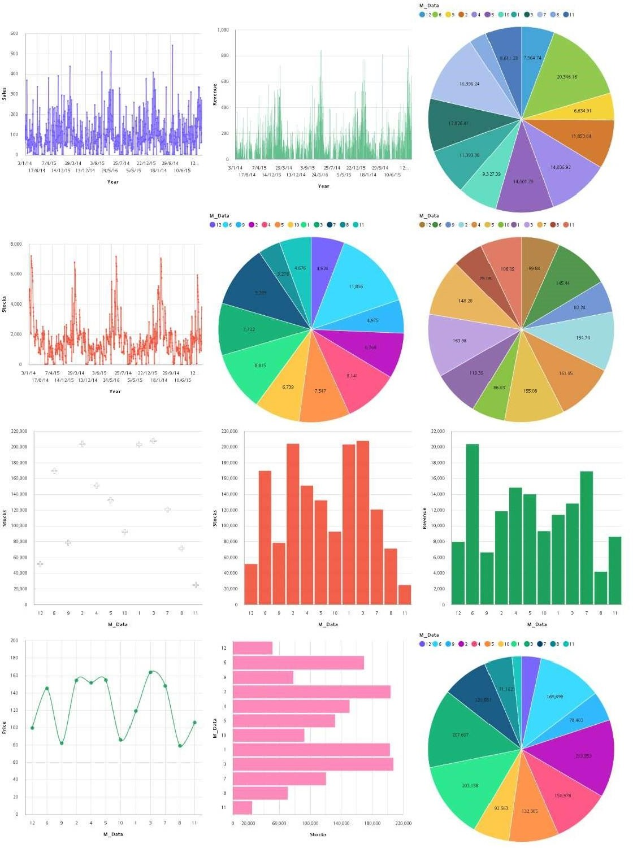

Report Creation:

## SALES BY YEAR, MONTHLY REVENUE, REVENUE BY YEAR

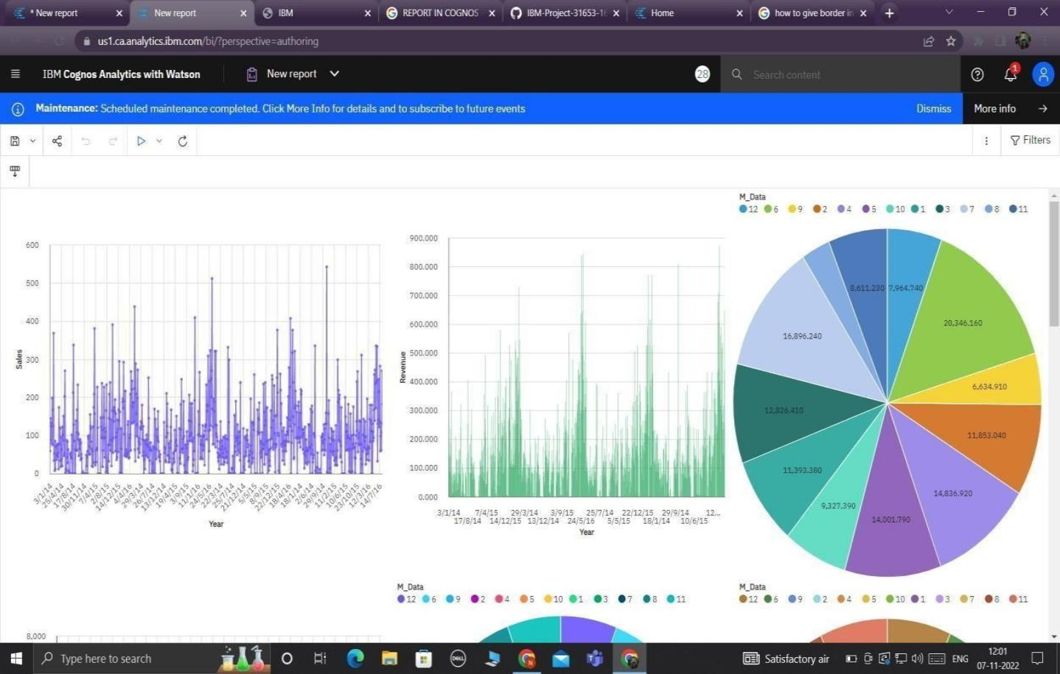

1. MONTHLY SALES

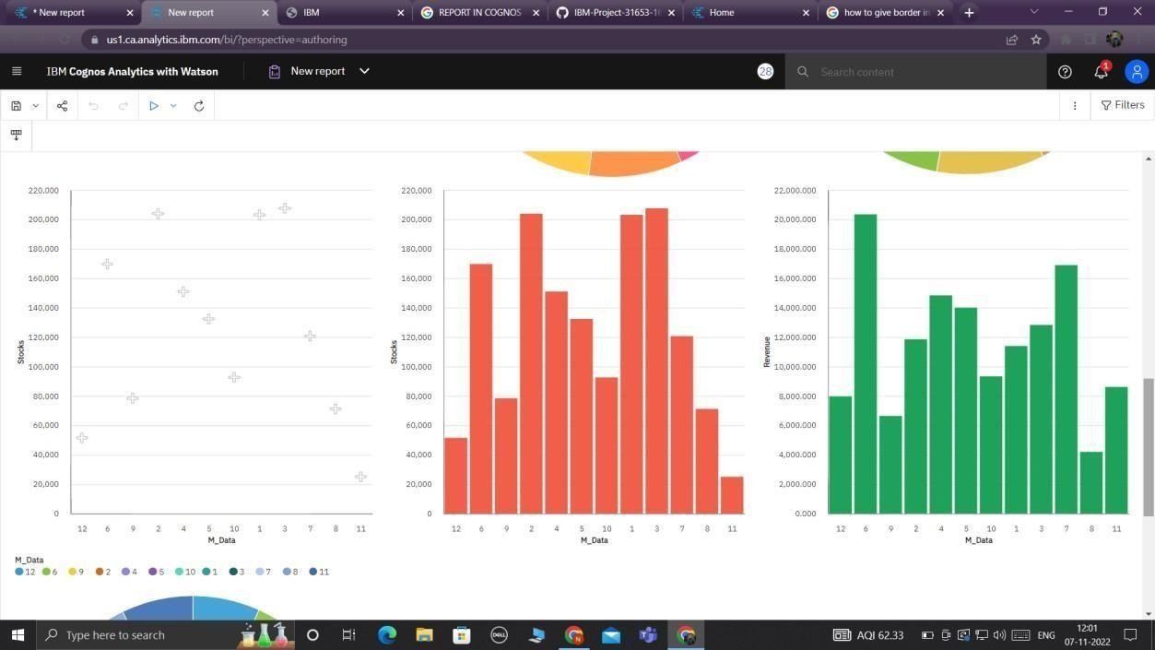

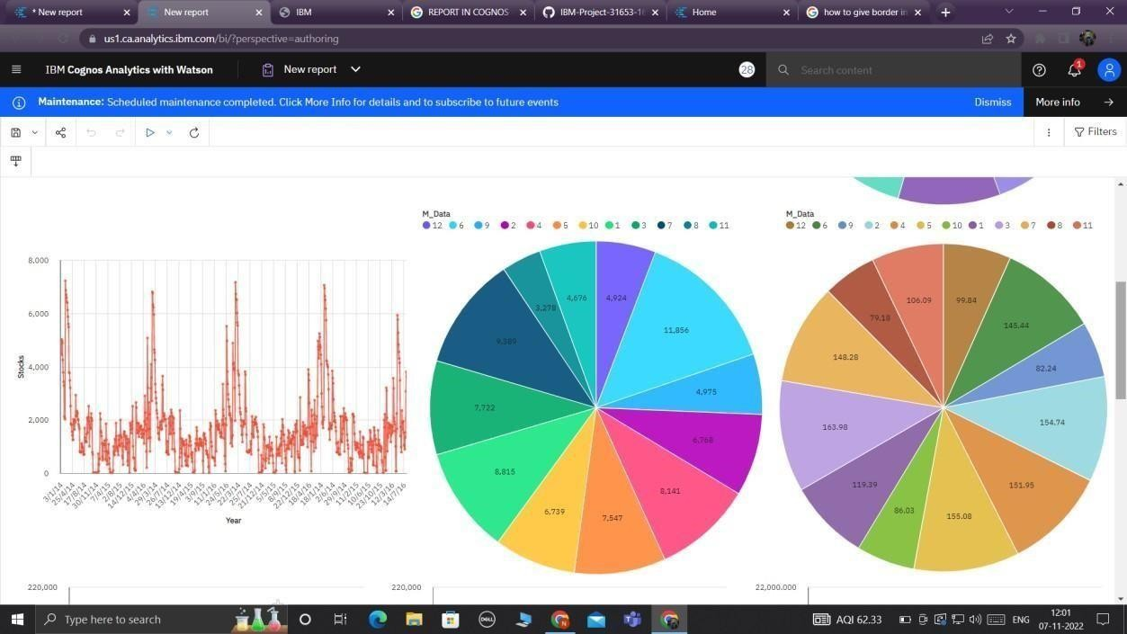

## MONTHLY STOCKS AND REVENUE

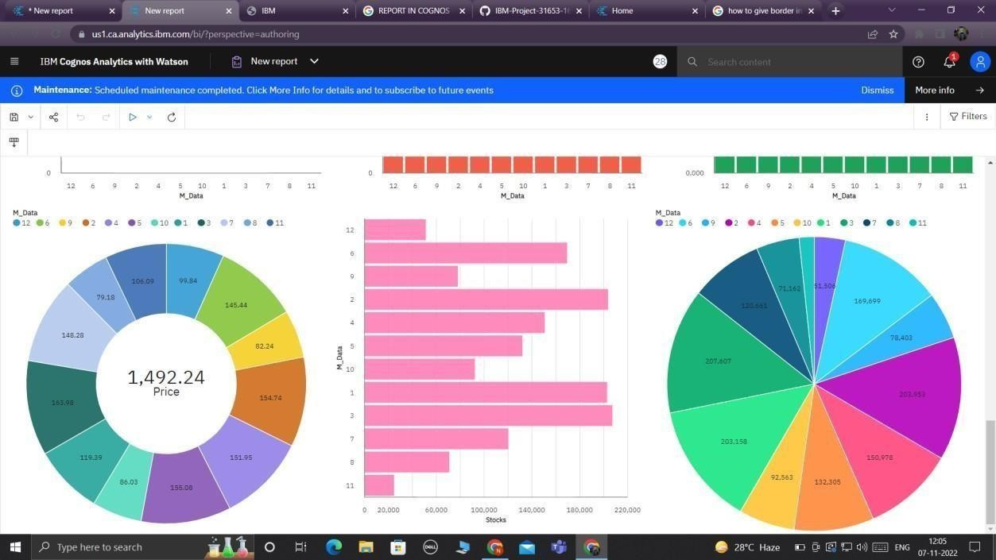

**CONCLUSION**

## For the success of the program, the managers of the retail stores must formulate a modern way of managing the inventory by instituting electronic systems to take care of the resources of the company. This ensures that they can be accounted for and there are proper records available all the time for reference to be made when the need arises. Besides, the retail management system is necessary for ensuring that there is accountability in the way the company handles its stock. It helps in saving time.

Retail companies have acquired significant importance within several countries due to their high economic contribution. Therefore, the need to analyze their KPIs becomes highly significant, as well as their different systems, methodologies, and tools used within inventory management and optimization. From the aspects mentioned above, the main trends in inventory management within companies were defined.

**REFERENCES**

1. R. Ishfaq, C. C. Defee, B. J. Gibson, y U. Raja, “Realignment of the physical distribution process in omni-channel fulfillmen t”, International Journal of Physical Distribution & Logistics Management, vol. 46, núm. 6/7, pp. 543–561, jul. 2016, doi: 10.1108/IJPDLM-02- 2015-0032.
2. J. Kembro y A. Norrman, “Exploring trends, implications and challenges for logistics information systems in omni-channels : Swedish retailers’ perception”, International Journal of Retail and Distribution Management, vol. 47, núm. 4, pp. 384–411, 2019, doi: 10.1108/IJRDM-07-2017-0141.
3. G. Hançerlioğulları, A. Şen, y E. A. Aktunç, “Demand uncertainty and inventory turnover performance: an empirical analysis of the US retail industry”, International Journal of Physical Distribution and Logistics Management, vol. 46, núm. 6–7, pp. 681–708, 2016, doi: 10.1108/IJPDLM-12-2014-0303.
4. J. D. Sterman y G. Dogan, “‘I’m not hoarding, i’m just stocking up before the hoarders get here.’: Behavioral causes of phantom ordering in supply chains”, Journal of Operations Management, vol. 39, pp. 6– 22, 2015.
5. Y. Wang, S. W. Wallace, B. Shen, y T.-M. Choi, “Service supply chain management: A review of operational models”, European Journal of Operational Research, vol. 247, núm. 3, pp. 685–698, 2015.
6. S. Mahar y P. D. Wright, “The value of postponing online fulfillment decisions in multi- channel retail/e-tail organizations”, Computers & operations research, vol. 36, núm. 11, pp. 3061–3072, 2009.
7. A. Hübner, A. Holzapfel, y H. Kuhn, “Operations management in multi-channel retailing: an exploratory study”, Operations Management Research, vol. 8, núm. 3–4, pp. 84–100, 2015.
8. A. Hübner, H. Kuhn, J. Wollenburg, y A. Trautrims, “From bricks-andmortar to bricks- and-clicks–logistics networks in omni-channel grocery retailing”, Empirical Studies in Multi-Channel and OmniChannel Retail Operations and Logistics, p. 102, 2018.
9. A. Fink, Conducting research literature reviews: From the internet to paper. Sage publications, 2019.
10. A. Cooke, D. Smith, y A. Booth, “Beyond PICO: the SPIDER tool for qualitative

evidence synthesis”, Qualitative health research, vol. 22, núm. 10, pp. 1435–1443, 2012